

Fight鯉魚王

目錄

一、故事背景------------------------------------------------------ 2

二、系統UML圖-------------------------------------------------- 3

三、遊戲畫面--------------------------------------------------- 4-7

四、程式碼----------------------------------------------------- 8-37

五、工作分配---------------------------------------------------- 38

# 一、故事背景

來自阿羅拉的莉莉艾，為了學習關都地區和阿羅拉地區的神奇寶貝有何不同，選完初始神奇寶貝後便踏上了旅程，在途中看到了伊布、卡比獸……等的關都神奇寶貝，莉莉艾認識了許多沒看過的神奇寶貝，也順利的捕抓到了野生的神奇寶貝，當然也進行了對戰，雖然剛開始常常失敗，但隨著時間的一天一天過去，莉莉艾當然也有所成長。

來自真新鎮的小茂，為了成為一名神奇寶貝大師並且打倒他的對手小智，他也開始了他的修煉之旅，他的神奇寶貝數量不但很多，還各個的是他親自培養出來的菁英，在戰鬥過程學到躲避的技術，相信神奇寶貝的心情，當然還有神奇寶貝的攻擊組合，收集到5個道館徽章的他，只剩下最後一個徽章便能參加神奇寶貝聯盟。

# 二、系統UML圖

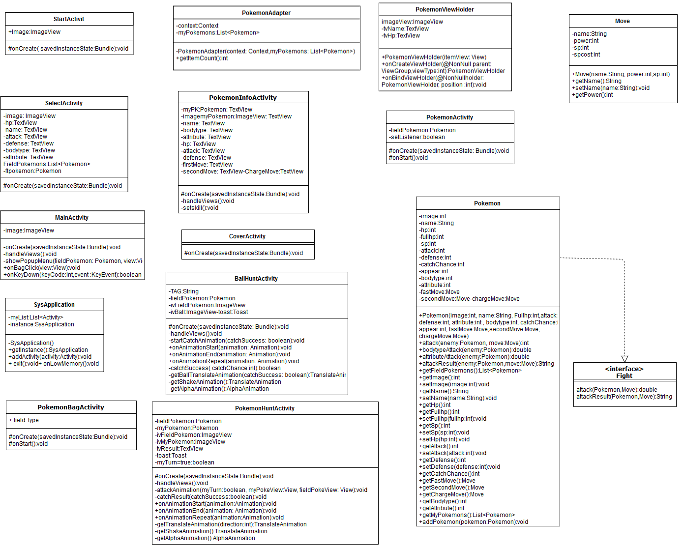

# 三、遊戲畫面

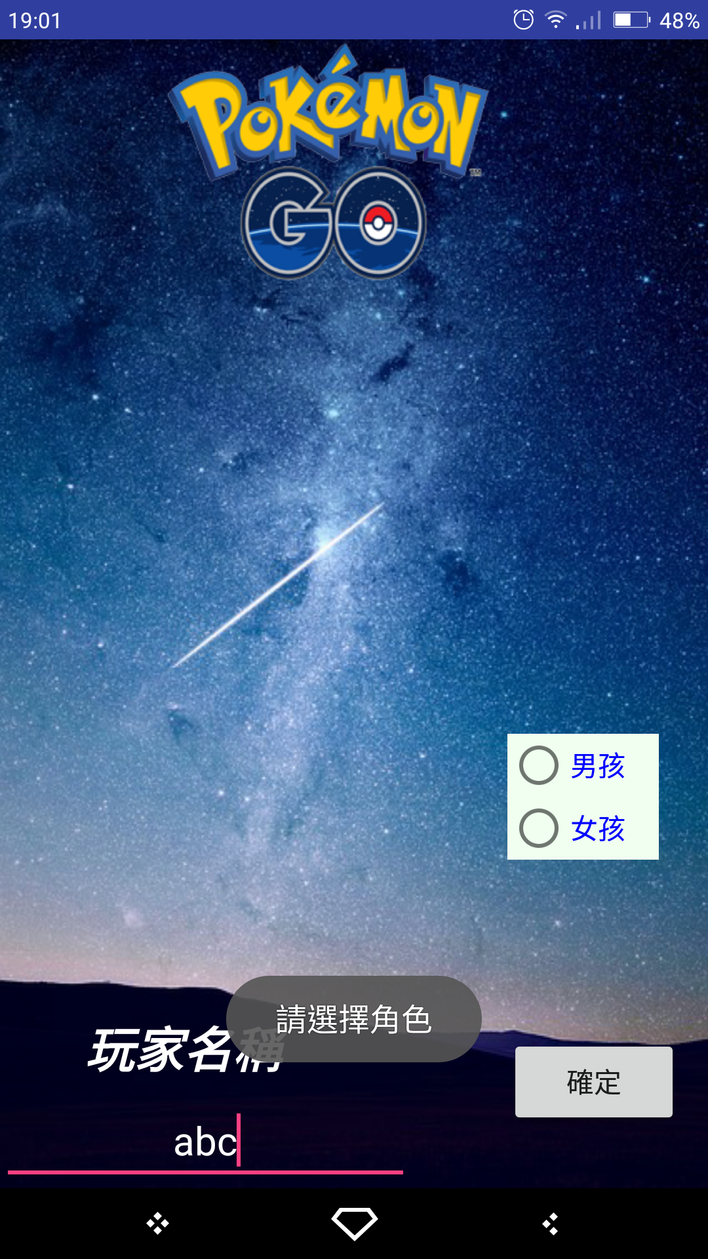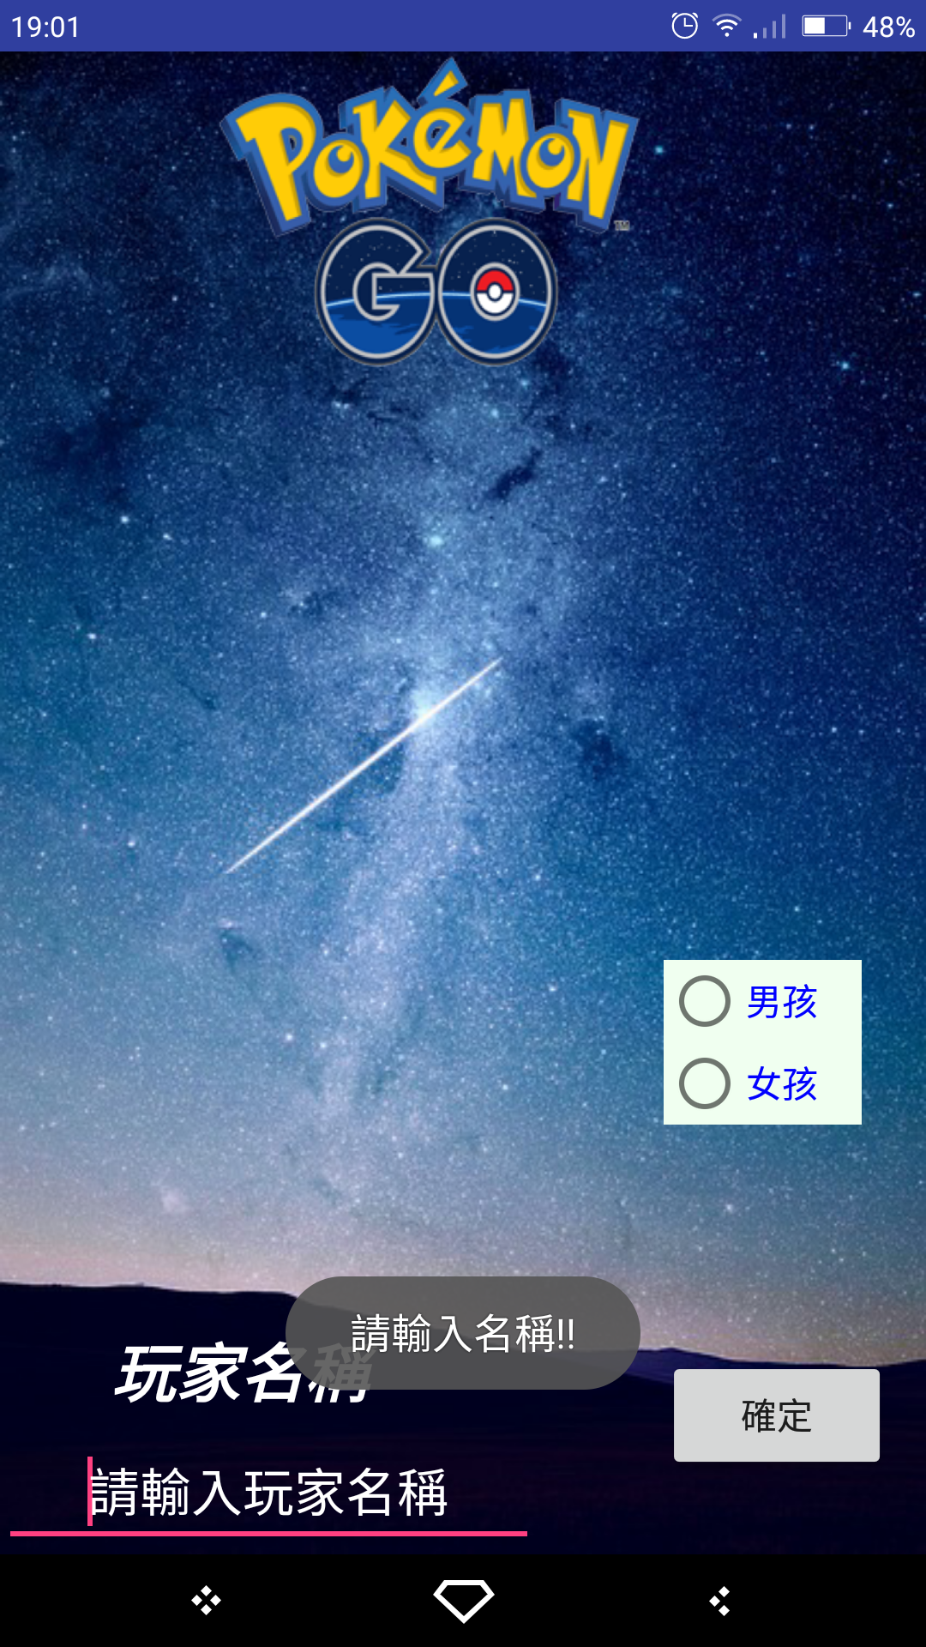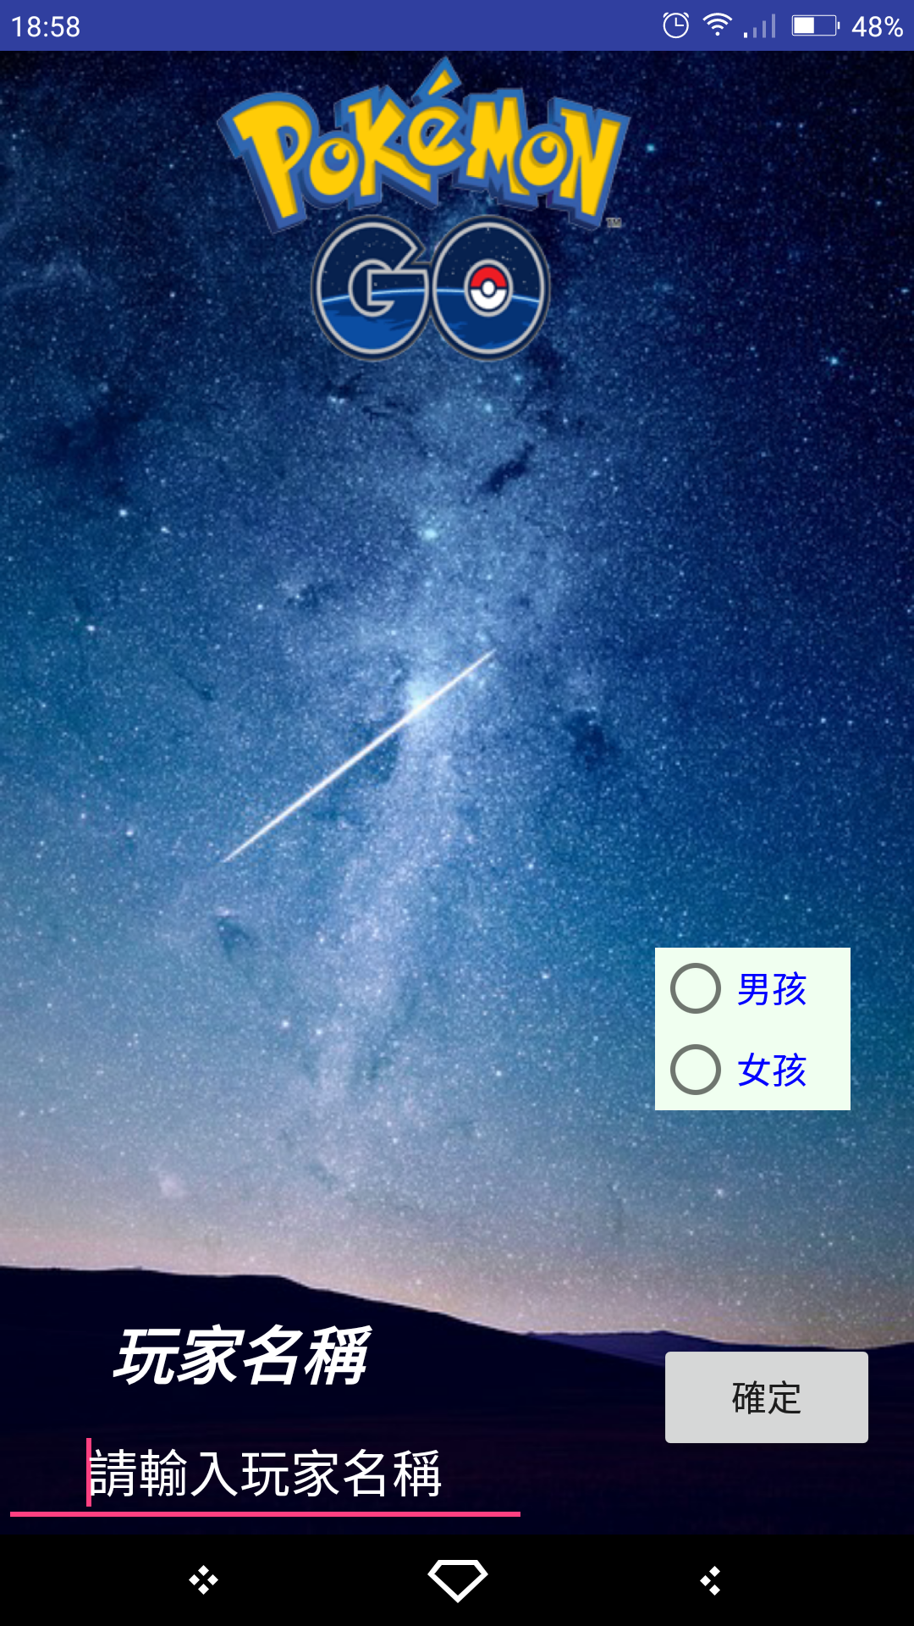

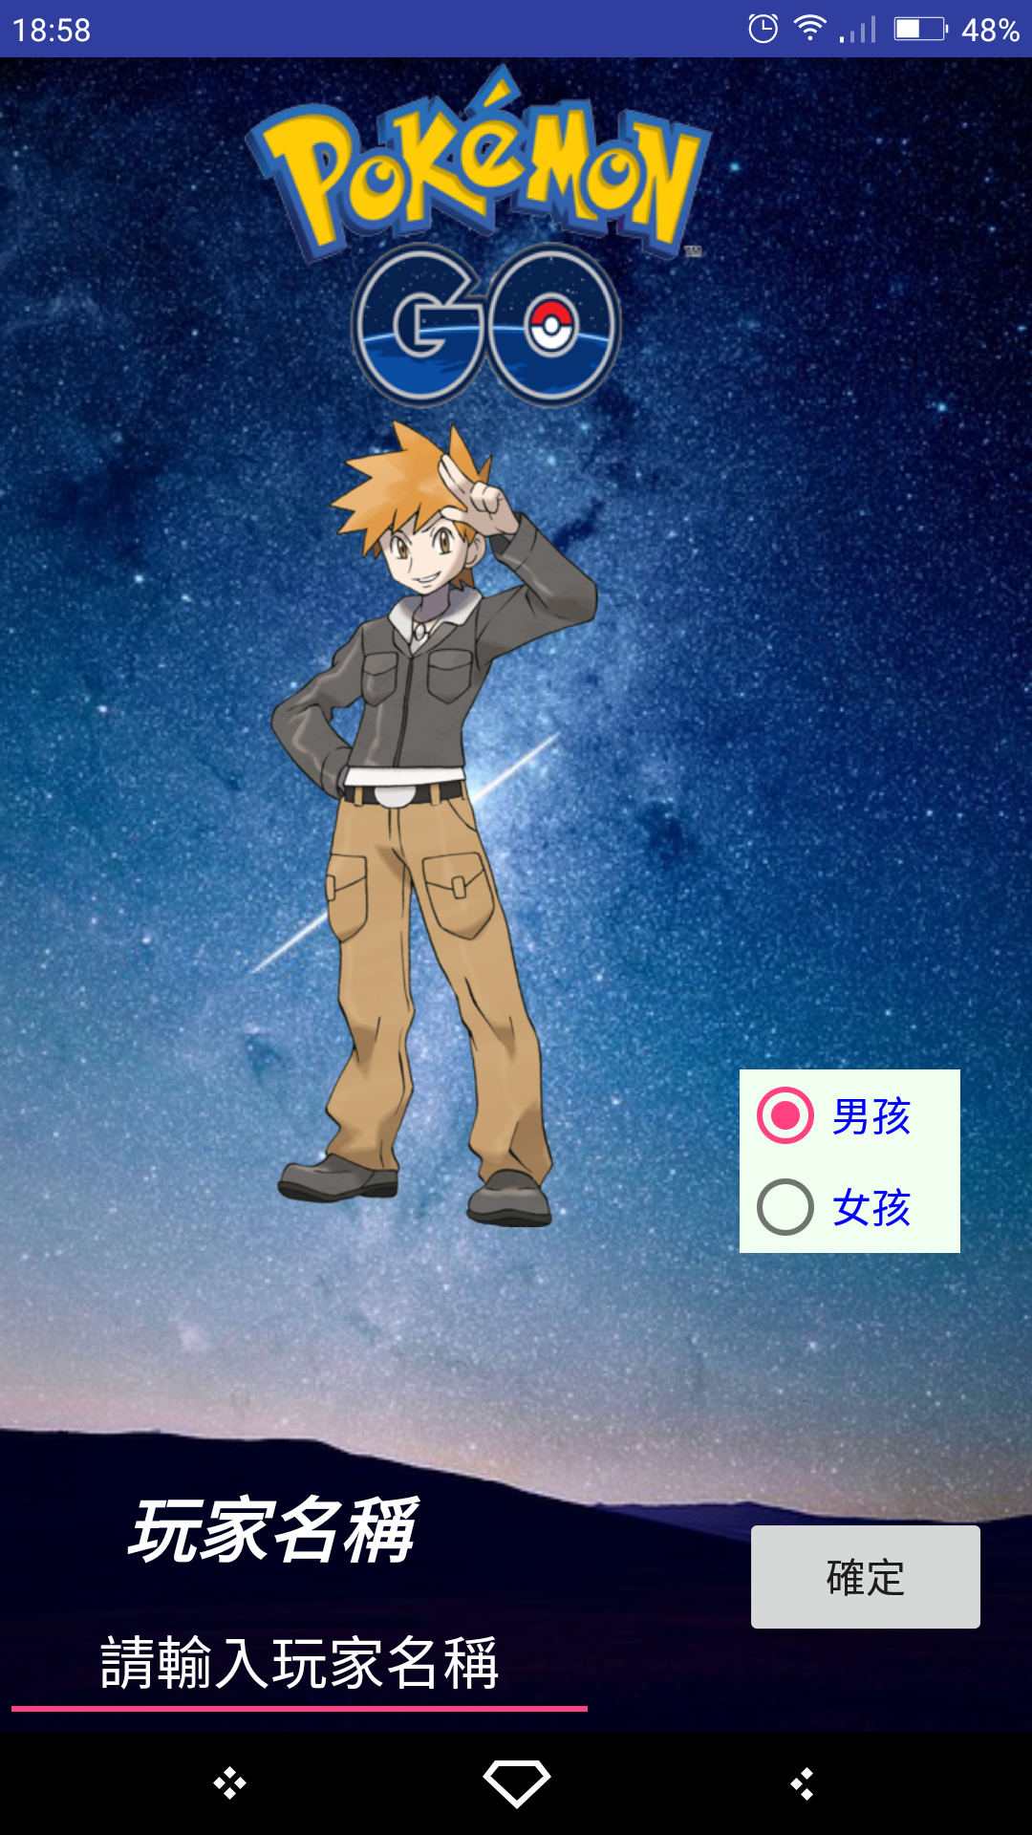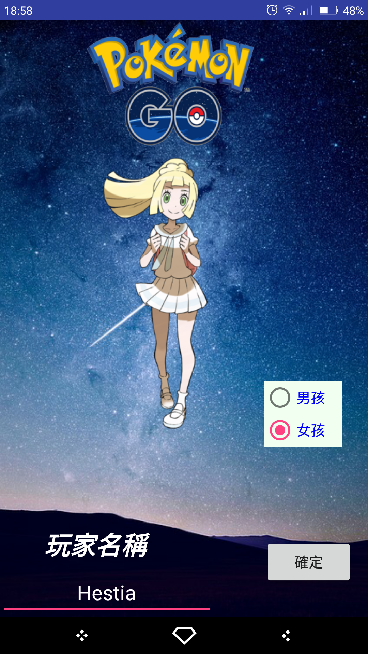登入畫面（沒輸入則跳出錯誤氣泡）

選初始神奇寶貝

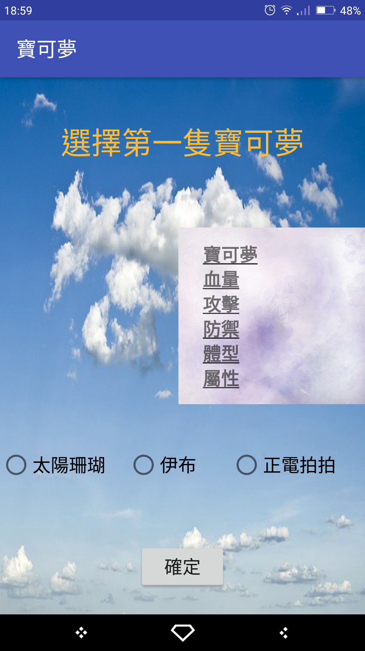

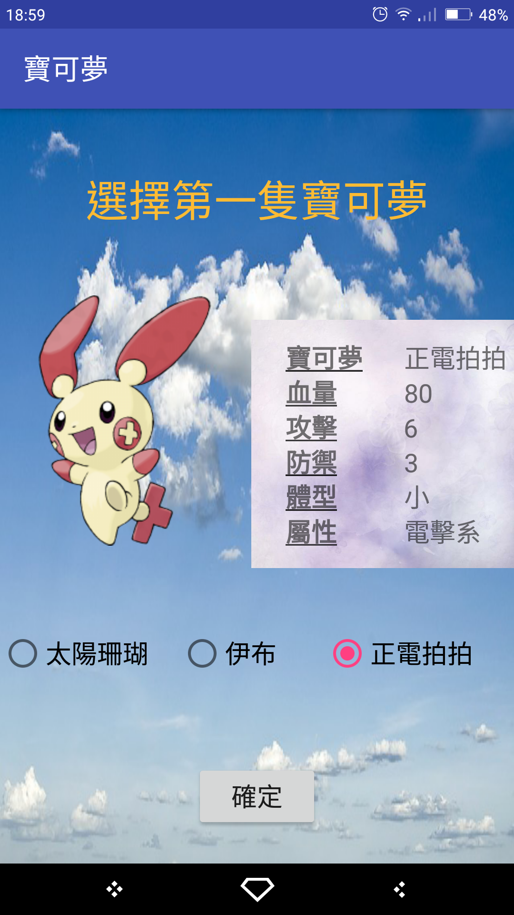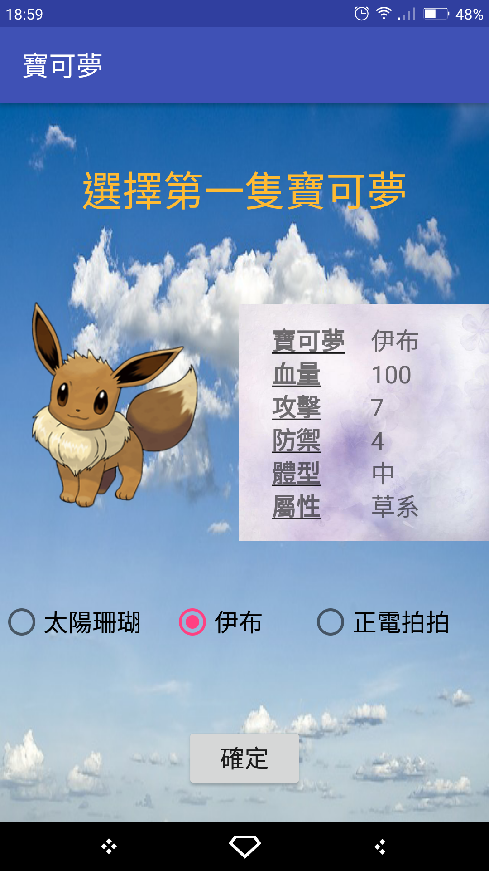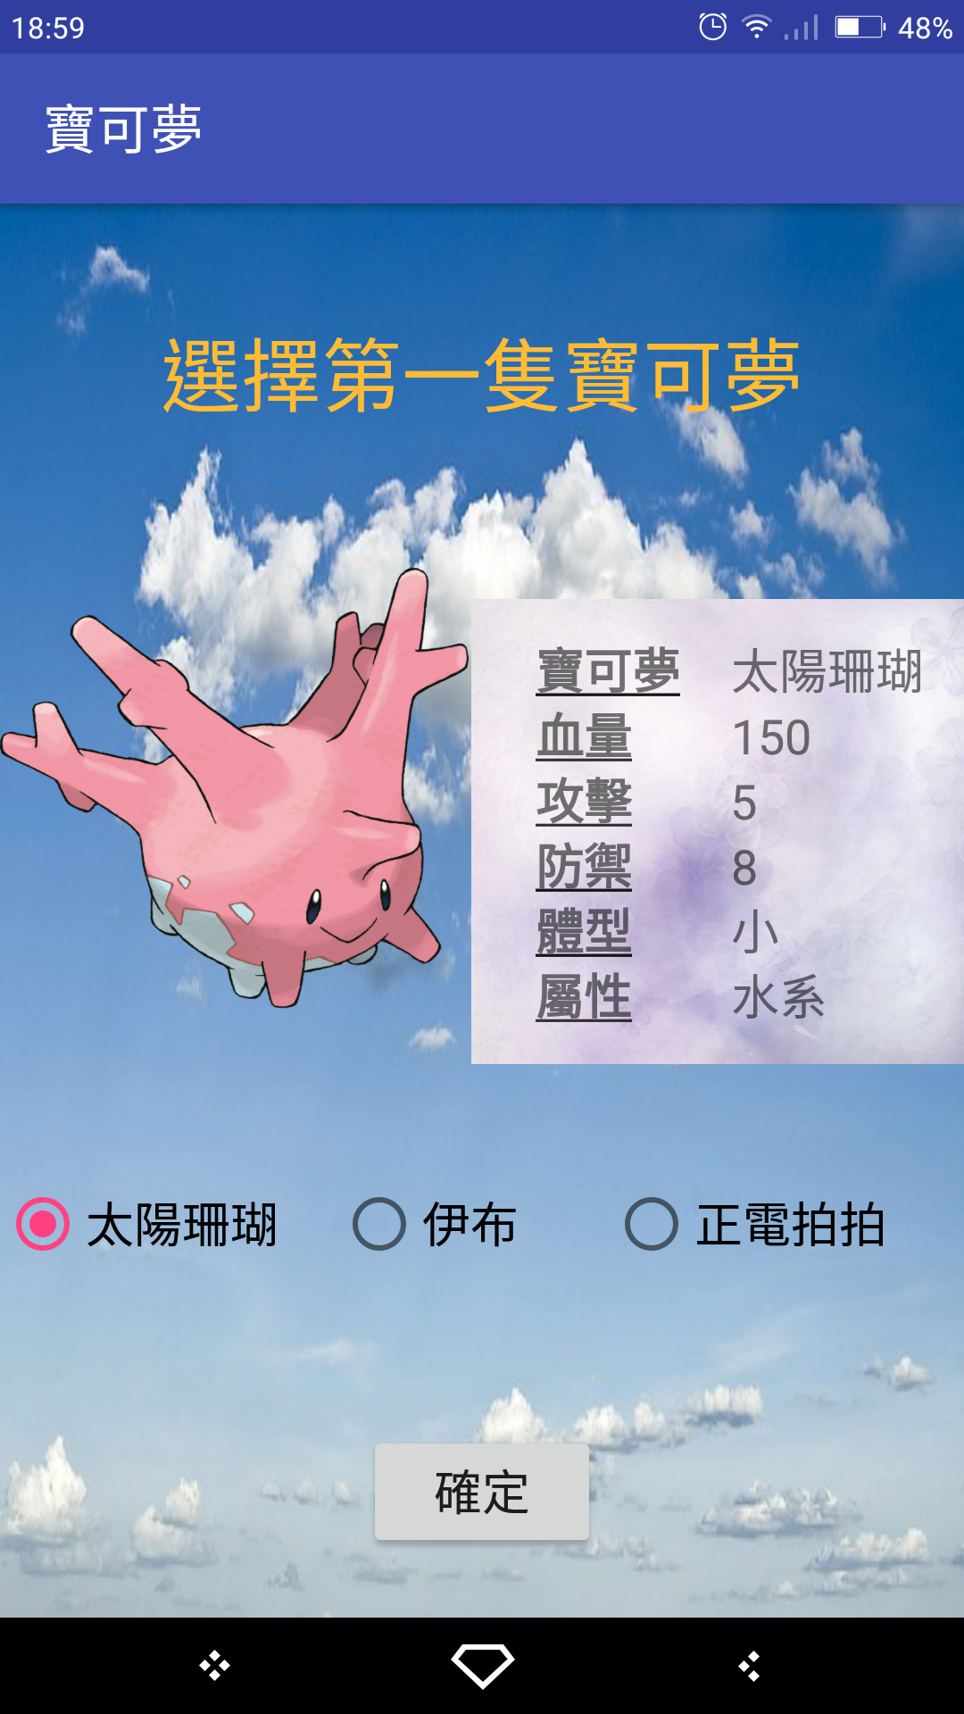

主頁面

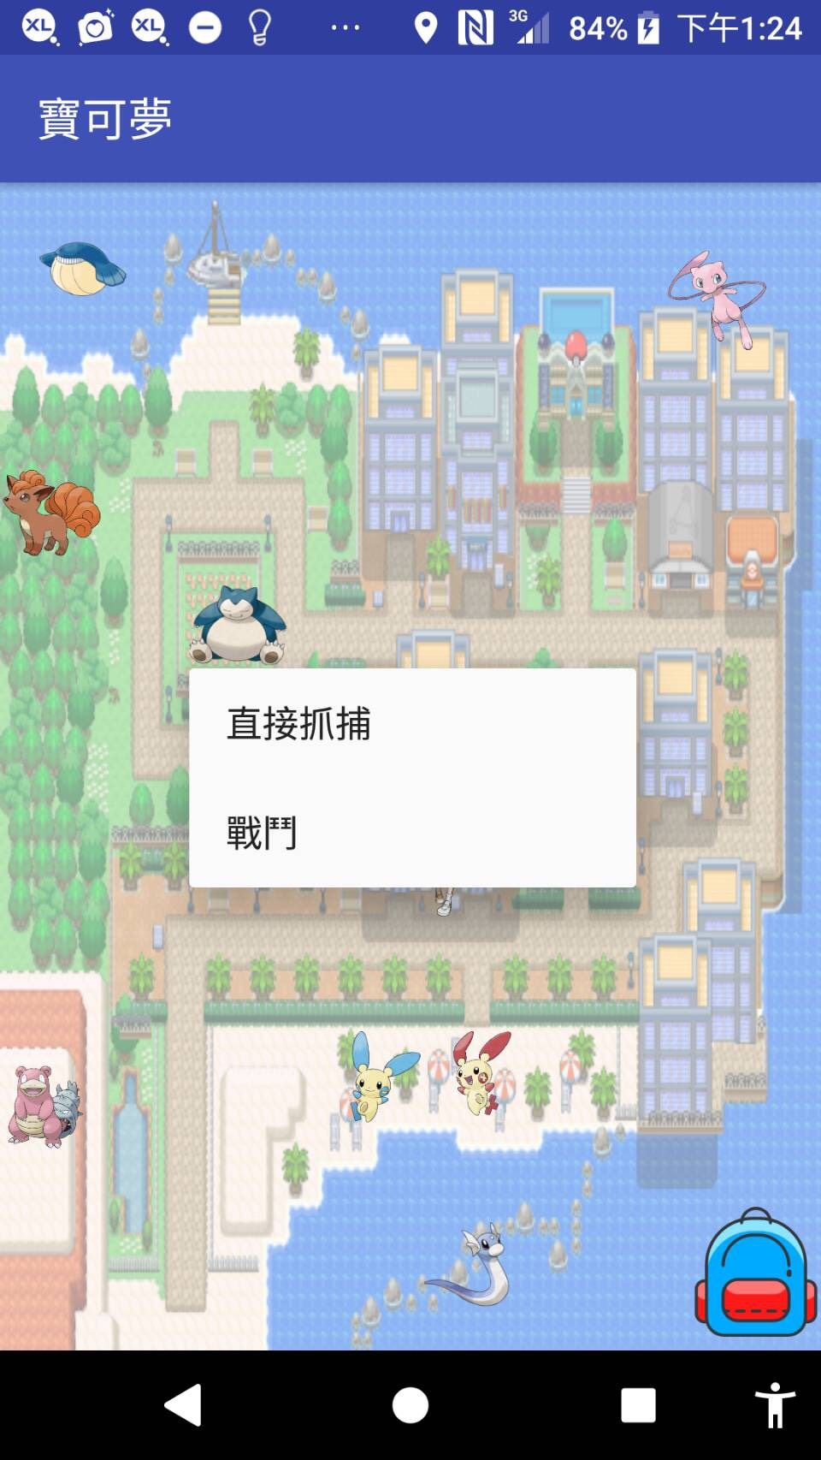

捕捉畫面:捕抓失敗會跳回主頁

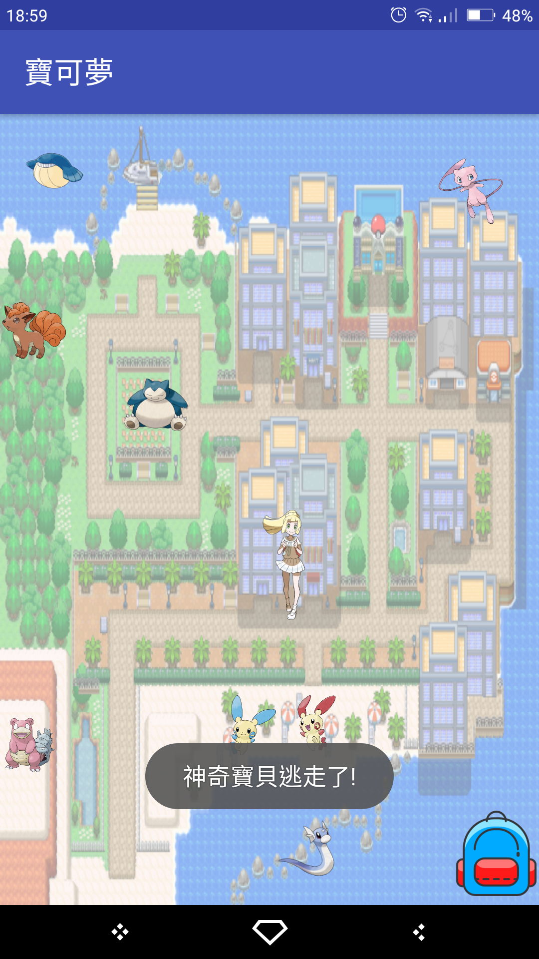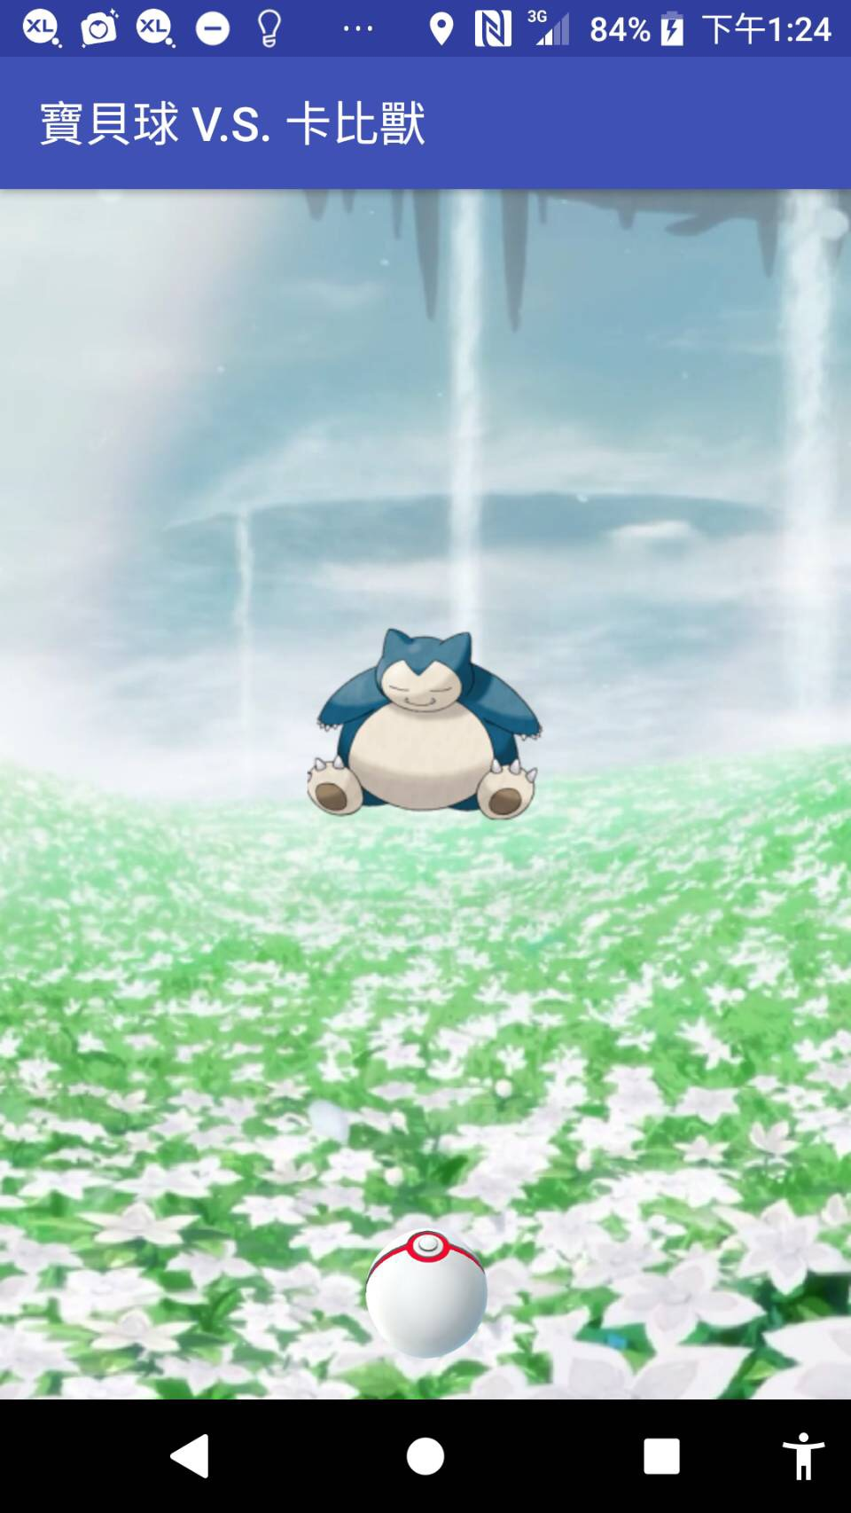

戰鬥選擇頁面＆戰鬥頁面 寶可夢背包

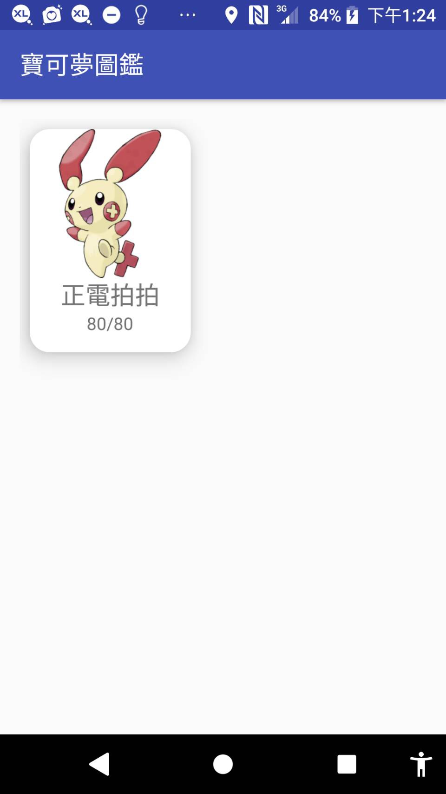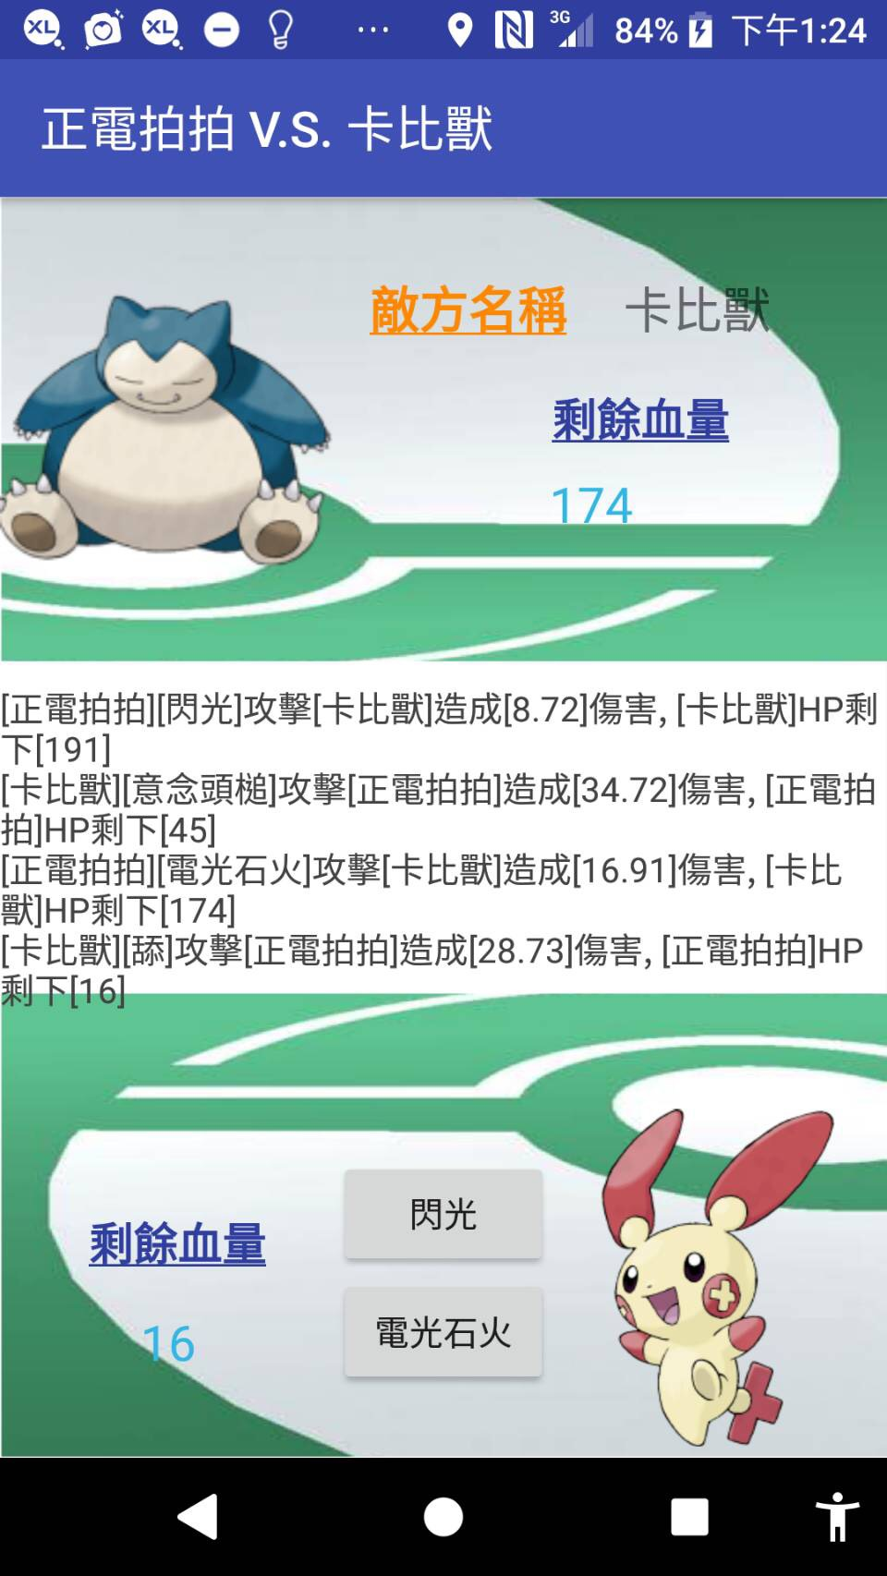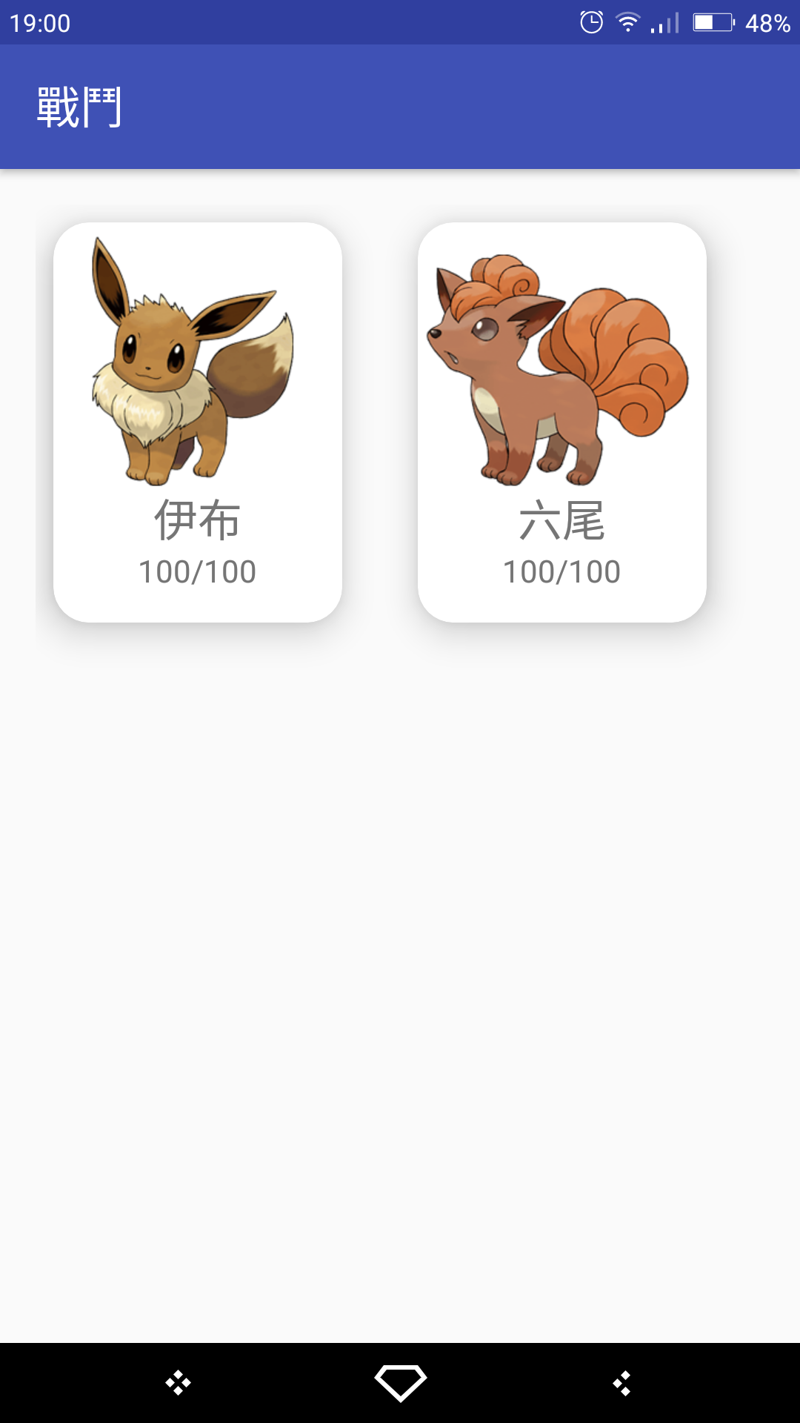選擇戰鬥寶可夢後進入戰鬥頁面 選擇寶可夢後進入資訊頁

資訊頁

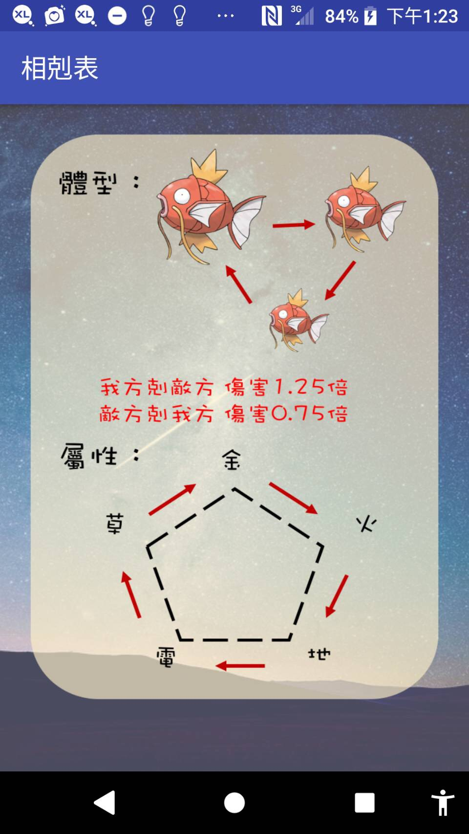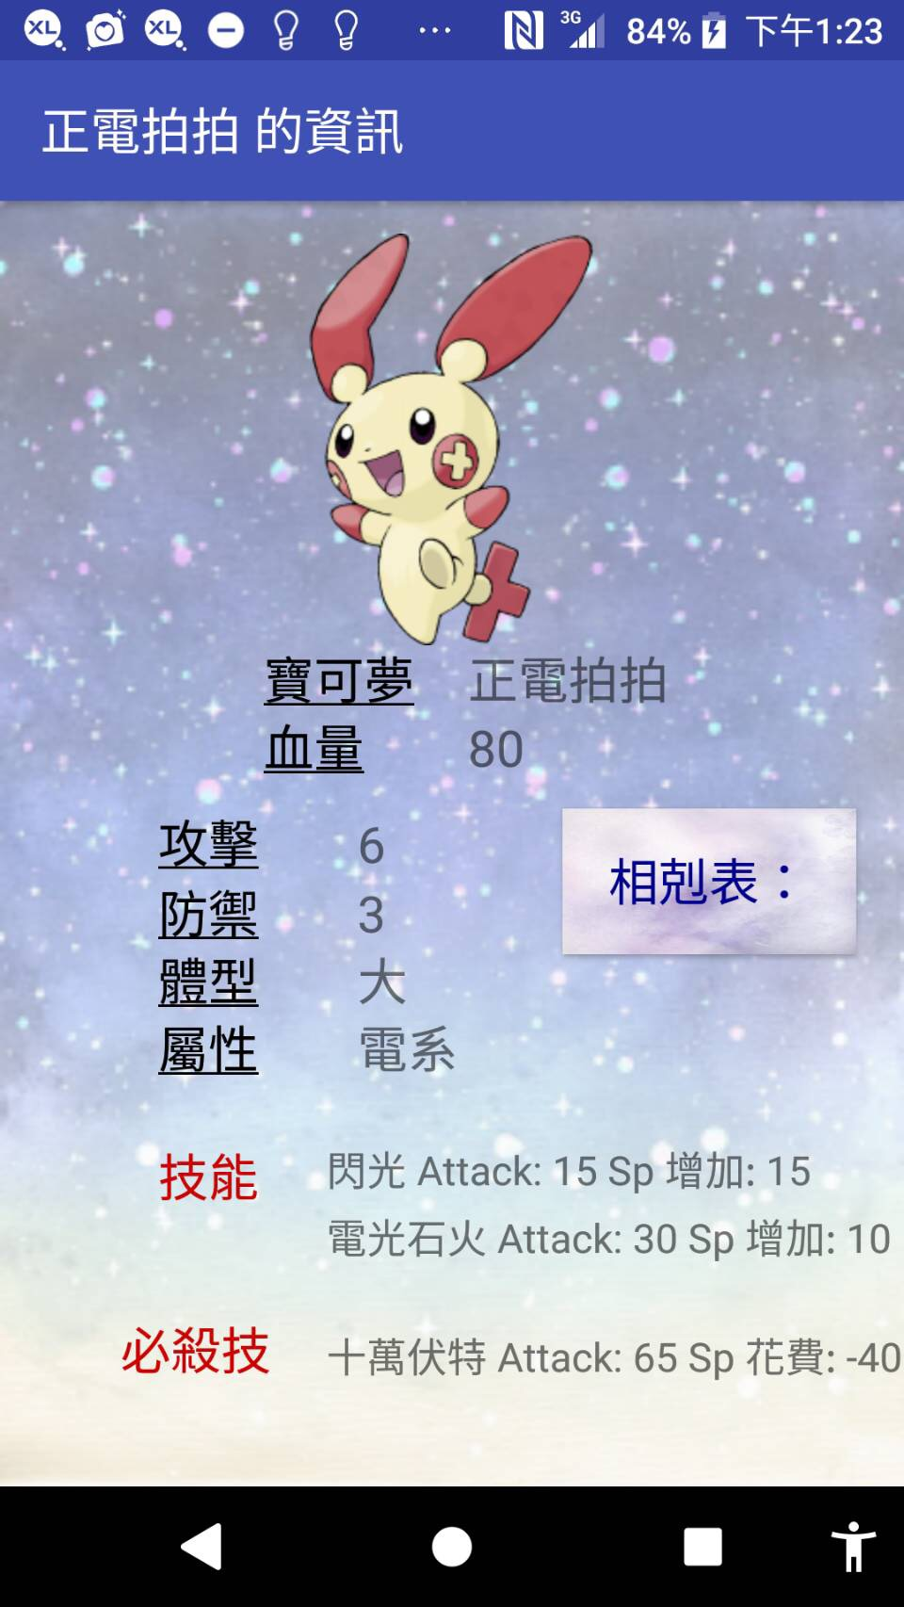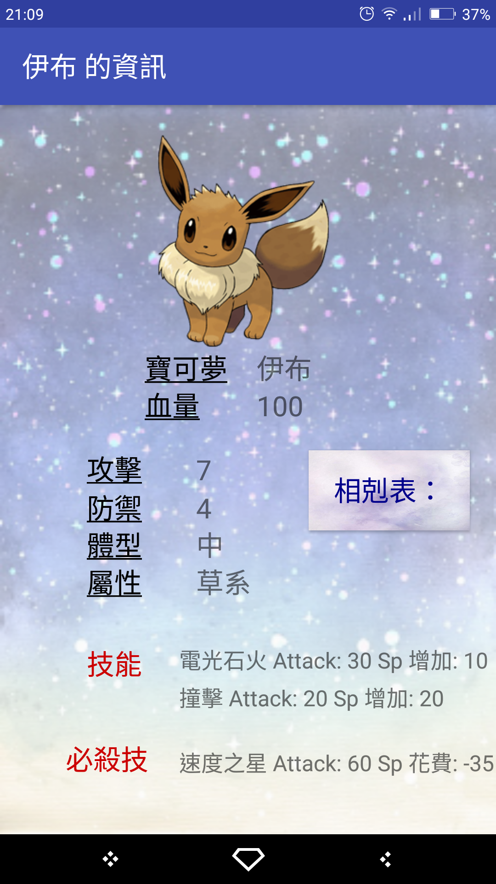點選相剋表後進入相剋表頁面

# 四、程式碼

### Pokemon

**package** idv.ron.oogame_poke.model;  
  
**import** java.io.Serializable;  
**import** java.util.ArrayList;  
**import** java.util.List;  
  
**import** idv.ron.oogame_poke.R;  
**import** idv.ron.oogame_poke.model.action.Fight;  
**import** idv.ron.oogame_poke.model.skill.Move;  
  
*/**  
 * 寶可夢精靈，參看寶可夢Go全圖鑑（http://www.otaku-hk.com/pkmgo/en/pokedex）  
 */***public class** Pokemon **implements** Fight, Serializable {  
 **private static** List<Pokemon> *myPokemons* = **new** ArrayList<>();  
  
 *// 圖片* **private int image**;  
 *// 名稱* **private** String **name**;  
 *// 血* **private int hp**;  
 **private int Fullhp**;  
 **private int sp**;  
 *// 攻擊力* **private int attack**;  
 *// 防禦力* **private int defense**;  
 *// 捕捉率* **private int catchChance**;  
 *//出現率* **private int appear**;  
 *//體型* **private int bodytype**;*//(1為大,2為中,3為小)  
 //屬性* **private int attribute**;*//1為電 2為木 3為水 4為火 5岩石 6無形  
 // 基本技能* **private** Move **fastMove**;  
 *// 基本技能2* **private** Move **secondMove**;  
 *// 特別技能* **private** Move **chargeMove**;  
  
  
 **public** Pokemon(**int** image, String name, **int** Fullhp, **int** attack, **int** defense,**int** attribute,**int** bodytype, **int** catchChance,**int** appear, Move fastMove,Move secondMove,Move chargeMove) {  
 **this**.**image** = image;  
 **this**.**name** = name;  
 **this**.**Fullhp** = Fullhp;  
 *//hp預設為滿* **this**.**hp** = getFullhp();  
 **this**.**attack** = attack;  
 **this**.**defense** = defense;  
 **this**.**attribute**=attribute;  
 **this**.**bodytype**=bodytype;  
 **this**.**catchChance** = catchChance;  
 **this**.**appear**=appear;  
 **this**.**fastMove** = fastMove;  
 **this**.**secondMove** = secondMove;  
 **this**.**chargeMove** = chargeMove;  
 }  
  
 @Override  
 **public double** attack(Pokemon enemy, Move move) {*//enemy是攻擊對象，move是技能名稱  
 // 傷害公式：(1+(自己.攻擊 – 敵人.防禦)*0.1 )*(技能傷害*屬性相剋*體型相剋)  
 // 基本傷害：(1+(自己.攻擊 – 敵人.防禦)*0.1 )* **double** Damage1=1+(getAttack()-enemy.getDefense())*0.1;  
 *// 後方公式：(技能傷害*屬性相剋*體型相剋)* **double** Damage2=move.getPower()*bodytypeAttack(enemy)*attributeAttack(enemy);  
  
 *// 合併傷害* **double** resultDamage =(**double**)(Damage1*Damage2);  
 **double** random=(70+Math.*random*()*50)*0.01;*//70%攻擊固定，30%浮動攻擊* resultDamage=resultDamage*random;  
 resultDamage=(**int**)(Math.*round*(resultDamage*100.0))/100.0;  
 resultDamage = resultDamage >= 0 ? resultDamage : 0;  
 *// 敵人依照結果傷害計算損失的HP，HP為負值則改為0* **int** hp = (**int**)(enemy.getHp() - resultDamage);  
  
 enemy.setHp(hp > 0 ? hp : 0);  
 **return** resultDamage;  
 }  
 **public double** bodytypeAttack(Pokemon enemy){  
 **if**((getBodytype()-enemy.getBodytype())==1){*//我方體型大於敵方體型一號（大>中、中>小）* **return** 1.25;  
 }**else if**((enemy.getBodytype()-getBodytype())==1){*//敵方體型比我方大一號* **return** 0.75;  
 }**else if**((enemy.getBodytype()==3)&&(getBodytype()==1)){*//敵方大 我方小* **return** 1.25;  
 }**else if**((enemy.getBodytype()==1)&&(getBodytype()==3)){*//敵方小 我方大* **return** 0.75;  
 }**else**{  
 **return** 1.00;  
 }  
 }  
 **public double** attributeAttack(Pokemon enemy){  
 **if**(getAttribute()==6){  
 **return** 1.25;  
 }**else if**((getAttribute()-enemy.getAttribute()==1)){*//我方剋敵方* **return** 1.25;  
 }**else if**((getAttribute()-enemy.getAttribute()==-1)){*//敵方剋我方* **return** 0.75;  
 }**else if**(getAttribute()==5&&enemy.getAttribute()==1){*//土剋金* **return** 1.25;  
 }**else if**(getAttribute()==1&&enemy.getAttribute()==5){  
 **return** 0.75;  
 }**else**{  
 **return** 1.00;  
 }  
 }  
*//double totalDamage = getAttack() + move.getPower();* @Override  
 **public** String attackResult(Pokemon enemy, Move move) {  
 **double** resultDamage = **this**.attack(enemy, move);  
 String text = String.*format*(  
 **"[%s][%s]攻擊[%s]造成[%s]傷害, [%3$s]HP剩下[%s]"**,  
 **this**.getName(), move.getName(), enemy.getName(), resultDamage, enemy.getHp());  
 **return** text;  
 }  
  
 */**  
 * 取得野生寶可夢  
 \** ***@return*** *回傳野生寶可夢  
 */* **public static** List<Pokemon> getFieldPokemons() {  
 List<Pokemon> pokemons = **new** ArrayList<>();  
 Pokemon eevee = **new** Pokemon(R.drawable.***eevee***,  
 **"伊布"**,  
 100,  
 7,  
 4,2,2,  
 30,40,  
 **new** Move(**"電光石火"**,30,10),*//技能1* **new** Move(**"撞擊"**, 20,20),  
 **new** Move(**"速度之星"**,60, -35)  
 );  
 Pokemon corsola = **new** Pokemon(R.drawable.***corsola***,  
 **"太陽珊瑚"**,  
 150,  
 5,  
 8,3,3,50,55,  
 **new** Move(**"泡沫"**,25,10),*//技能1* **new** Move(**"撞擊"**, 20,20),  
 **new** Move(**"泡沫光線"**,45, -25)  
 );  
 Pokemon pulse = **new** Pokemon(R.drawable.***pulse***,  
 **"正電拍拍"**,  
 80,  
 6,  
 3,1,1,50,70,  
 **new** Move(**"閃光"**,15,15),*//技能1* **new** Move(**"電光石火"**, 30,10),  
 **new** Move(**"十萬伏特"**,65, -40)  
 );  
 Pokemon vulpix = **new** Pokemon(R.drawable.***vulpix***,  
 **"六尾"**,  
 100,  
 7,  
 4,2,2,20,50,  
 **new** Move(**"火花"**,20,20),*//技能1* **new** Move(**"電光石火"**, 30,10),  
 **new** Move(**"火焰衝擊"**,70, -45)  
 );  
 Pokemon minun = **new** Pokemon(R.drawable.***minun***,  
 **"負電拍拍"**,  
 80,  
 6,  
 3,1,1,50,70,  
 **new** Move(**"閃電"**,15,15),*//技能1* **new** Move(**"電光石火"**, 30,10),  
 **new** Move(**"放電"**,55, -35)  
 );  
 Pokemon mew = **new** Pokemon(R.drawable.***mew***,  
 **"夢幻"**,  
 250,  
 10,  
 6,6,1,5,5,  
 **new** Move(**"陽光烈焰"**,40,20),*//技能1* **new** Move(**"心靈幻象"**, 50,10),  
 **new** Move(**"龍之波動"**,100, -50)  
 );  
 Pokemon dratini = **new** Pokemon(R.drawable.***dartini***,  
 **"迷你龍"**,  
 150,  
 8,  
 4,3,1,20,35,  
 **new** Move(**"噬咬"**,25,15),*//技能1* **new** Move(**"龍之吐息"**, 30,10),  
 **new** Move(**"龍捲風"**,50, -40)  
 );  
 Pokemon snorlax = **new** Pokemon(R.drawable.***snorlax***,  
 **"卡比獸"**,  
 200,  
 6,  
 10,5,3,30,20,  
 **new** Move(**"意念頭槌"**,35,10),*//技能1* **new** Move(**"舔"**, 25,25),  
 **new** Move(**"破壞死光"**,70, -50)  
 );  
 Pokemon wailmer = **new** Pokemon(R.drawable.***wailmer***,  
 **"吼吼鯨"**,  
 180,  
 5,  
 8,3,3,30,30,  
 **new** Move(**"噴水"**,30,10),*//技能1* **new** Move(**"壓制"**, 15,20),  
 **new** Move(**"水之波動"**,60, -45)  
 );  
 Pokemon slowbro = **new** Pokemon(R.drawable.***slowbro***,  
 **"呆河馬"**,  
 180,  
 8,  
 6,3,3,25,25,  
 **new** Move(**"念力"**,35,5),*//技能1* **new** Move(**"噴水"**, 30,10),  
 **new** Move(**"冷凍光束"**,70, -35)  
 );  
  
 pokemons.add(eevee);  
 pokemons.add(corsola);  
 pokemons.add(pulse);  
 pokemons.add(vulpix);  
 pokemons.add(minun);  
 pokemons.add(mew);  
 pokemons.add(dratini);  
 pokemons.add(snorlax);  
 pokemons.add(wailmer);  
 pokemons.add(slowbro);  
  
 **return** pokemons;  
 }  
  
 **public int** getImage() {  
 **return image**;  
 }  
  
 **public void** setImage(**int** image) {  
 **this**.**image** = image;  
 }  
  
 **public** String getName() {  
 **return name**;  
 }  
  
 **public void** setName(String name) {  
 **this**.**name** = name;  
 }  
  
 **public int** getHp() {  
 **return hp**;  
 }  
  
 **public int** getFullhp() { **return Fullhp**; }  
  
 **public void** setFullhp(**int** fullhp) { **Fullhp** = fullhp; }  
  
 **public int** getSp() { **return sp**; }  
  
 **public void** setSp(**int** sp) { **this**.**sp** = sp; }  
  
 **public void** setHp(**int** hp) {  
 **this**.**hp** = hp;  
 }  
  
 **public int** getAttack() {  
 **return attack**;  
 }  
  
 **public void** setAttack(**int** attack) {  
 **this**.**attack** = attack;  
 }  
  
 **public int** getDefense() {  
 **return defense**;  
 }  
  
 **public void** setDefense(**int** defense) {  
 **this**.**defense** = defense;  
 }  
  
 **public int** getCatchChance() {  
 **return catchChance**;  
 }  
  
 *//捕捉率、技能、體型、屬性暫時不提供更改  
 //public void setCatchChance(int catchChance) {this.catchChance = catchChance;}* **public** String getFastMoveName(){**return fastMove**.getName();};  
 **public** String getSecondMoveName(){**return secondMove**.getName();};  
  
 **public** Move getFastMove() {  
 **return fastMove**;  
 }  
  
 **public** Move getSecondMove() {  
 **return secondMove**;  
 }  
  
 *//public void setFastMove(Move fastMove) {this.fastMove = fastMove;}* **public** Move getChargeMove() {  
 **return chargeMove**;  
 }  
  
 *//public void setChargeMove(Move chargeMove) {this.chargeMove = chargeMove;}* **public int** getBodytype() { **return bodytype**; }  
  
  
 **public int** getAttribute() { **return attribute**; }  
  
  
  
  
 **public static** List<Pokemon> getMyPokemons() {  
 **return** *myPokemons*;  
 }  
  
  
 **public static void** addPokemon(Pokemon pokemon) {  
 *myPokemons*.add(pokemon);  
 }  
 *//體型(1為大,2為中,3為小)  
 //屬性1為電 2為木 3為水 4為火 5岩石 6無形* **public** String getBodytupeText(){  
 **if**(**this**.getBodytype()==1){  
 **return "大"**;  
 }**else if** (**this**.getBodytype()==2){  
 **return "中"**;  
 }**else**{  
 **return "小"**;  
 }  
 }  
  
 **public** String getAttributeText(){  
 **if**(**this**.getAttribute()==1){  
 **return "電系"**;  
 }**else if**(**this**.getAttribute()==2){  
 **return "草系"**;  
 }**else if**(**this**.getAttribute()==3){  
 **return "水系"**;  
 }**else if**(**this**.getAttribute()==4){  
 **return "火系"**;  
 }**else if**(**this**.getAttribute()==5){  
 **return "岩石系"**;  
 }**else**{  
 **return "無形"**;  
 }  
 }  
}

### BallHuntActivity

**package** idv.ron.oogame_poke.controller;  
  
**import** android.os.Bundle;  
**import** android.support.v7.app.AppCompatActivity;  
**import** android.util.Log;  
**import** android.view.Gravity;  
**import** android.view.View;  
**import** android.view.animation.AlphaAnimation;  
**import** android.view.animation.Animation;  
**import** android.view.animation.CycleInterpolator;  
**import** android.view.animation.TranslateAnimation;  
**import** android.widget.ImageView;  
**import** android.widget.TextView;  
**import** android.widget.Toast;  
  
**import** idv.ron.oogame_poke.R;  
**import** idv.ron.oogame_poke.model.Pokemon;  
  
*// 精靈球捕捉頁面***public class** BallHuntActivity **extends** AppCompatActivity {  
 **private static final** String ***TAG*** = **"BallHuntActivity"**;  
 **private** Pokemon **fieldPokemon**;  
 **private** ImageView **ivFieldPokemon**, **ivBall**;  
 **private** Toast **toast**;  
 **private int time**=0,**a**;  
 **private** TextView **catchtime**;  
 **private** String **b**;  
  
 @Override  
 **protected void** onCreate(Bundle savedInstanceState) {  
 SysApplication.*getInstance*().addActivity(**this**);  
  
 **super**.onCreate(savedInstanceState);  
 setContentView(R.layout.***activity_ball_hunt***);  
 Bundle bundle = getIntent().getExtras();  
 **if** (bundle != **null**) {  
 **fieldPokemon** = (Pokemon) bundle.getSerializable(**"fieldPokemon"**);  
 }  
 String title = String.format(  
 getString(R.string.***textPokemonHunt***),  
 getString(R.string.***textBallHunt***), **fieldPokemon**.getName());  
 setTitle(title);  
 handleViews();  
 }  
  
 **private void** handleViews() {  
 **ivFieldPokemon** = findViewById(R.id.***ivFieldPokemon***);  
 **ivFieldPokemon**.setImageResource(**fieldPokemon**.getImage());  
  
 **catchtime**=findViewById(R.id.***catchtime***);  
  
  
 **ivBall** = findViewById(R.id.***ivBall***);  
 **ivBall**.setOnClickListener(**new** View.OnClickListener() {  
 @Override  
 **public void** onClick(View view) {  
 **time**++;  
 **a**=10-**time**;  
 **b**=Integer.*toString*(**a**);  
 String ct = String.format(getString(R.string.***remain***),**b**);  
 **catchtime**.setText(ct);  
 *// 點擊精靈球後依照亂數與捕捉率來決定是否抓到寶可夢* **boolean** catchSuccess = catchSuccess(**fieldPokemon**.getCatchChance());  
 *// 捕捉成功將精靈球設為disable，避免user繼續點擊攻擊* **if** (catchSuccess) {  
 **ivBall**.setEnabled(**false**);  
 }  
 startCatchAnimation(catchSuccess);  
 }  
 });  
  
 }  
  
 **private void** startCatchAnimation(**boolean** catchSuccess) {  
 *// 設定精靈球動畫* Animation ballAnimation = getBallTranslateAnimation(catchSuccess);  
 **ivBall**.startAnimation(ballAnimation);  
  
  
  
  
 **if** (catchSuccess) {  
 *// 抓到寶可夢，先存入我的百寶箱內* Pokemon.*getMyPokemons*().add(**fieldPokemon**);  
 *// 晃動寶可夢的ImageView代表被有效攻擊* Animation shakeAnimation = getShakeAnimation();  
 shakeAnimation.setAnimationListener(**new** Animation.AnimationListener() {  
 @Override  
 **public void** onAnimationStart(Animation animation) {  
 }  
  
 @Override  
 **public void** onAnimationEnd(Animation animation) {  
 *// 當晃動完畢後寶可夢變成透明（代表被抓而消失了）* Animation alphaAnimation = getAlphaAnimation();  
 alphaAnimation.setFillAfter(**true**);  
 alphaAnimation.setAnimationListener(**new** Animation.AnimationListener() {  
 @Override  
 **public void** onAnimationStart(Animation animation) {  
  
 }  
  
 *// 當ImageView變透明後，Toast「抓到xxx」並關閉此頁回到前頁* @Override  
 **public void** onAnimationEnd(Animation animation) {  
 **if** (**toast** != **null**) {  
 **toast**.cancel();  
 }  
 String text = String.format(  
 getString(R.string.***textPokemonCaught***), **fieldPokemon**.getName());  
 **toast** = Toast.makeText(  
 BallHuntActivity.**this**, text, Toast.***LENGTH_SHORT***);  
 **toast**.setGravity(Gravity.***CENTER_HORIZONTAL*** | Gravity.***CENTER_VERTICAL***, -200, 0);  
 **toast**.show();  
 finish();  
 }  
  
 @Override  
 **public void** onAnimationRepeat(Animation animation) {  
  
 }  
 });  
 **ivFieldPokemon**.startAnimation(alphaAnimation);  
 }  
  
 @Override  
 **public void** onAnimationRepeat(Animation animation) {  
 }  
 });  
 **ivFieldPokemon**.startAnimation(shakeAnimation);  
 } **else** {  
 *// 讓寶可夢暫時消失，代表沒抓到* Animation alphaAnimation = getAlphaAnimation();  
 alphaAnimation.setAnimationListener(**new** Animation.AnimationListener() {  
 @Override  
 **public void** onAnimationStart(Animation animation) {  
 }  
  
 *// 消失後Toast「逃跑了」* @Override  
 **public void** onAnimationEnd(Animation animation) {  
 *// 之前已經有Toast，立即cancel後再重新產生* **if** (**toast** != **null**) {  
 **toast**.cancel();  
 }  
 String text = String.format(getString(R.string.***textPokemonDodge***), **fieldPokemon**.getName());  
 **toast** = Toast.makeText(BallHuntActivity.**this**, text, Toast.***LENGTH_SHORT***);  
 **toast**.setGravity(Gravity.***CENTER_HORIZONTAL*** | Gravity.***CENTER_VERTICAL***, 200, 0);  
 **toast**.show();  
 }  
  
 @Override  
 **public void** onAnimationRepeat(Animation animation) {  
 }  
 });  
 **ivFieldPokemon**.startAnimation(alphaAnimation);  
  
 **if**(**time**>=10){  
 Toast toast = Toast.makeText(BallHuntActivity.**this**, **"神奇寶貝逃走了!"**, Toast.***LENGTH_LONG***);  
 toast.show();  
 finish();  
 }  
  
 }  
  
  
 }  
  
 **private boolean** catchSuccess(**int** catchChance) {  
 *// 產生1~100亂數* **int** chance = (**int**) (Math.*random*() * 100) + 1;  
 Log.*d*(***TAG***, **"chance = "** + chance + **"; catchSuccess = "** + catchChance);  
 *// 產生的亂數小於等於捕捉率即代表捕捉到* **return** chance <= catchChance;  
 }  
  
 **private** TranslateAnimation getBallTranslateAnimation(**boolean** catchSuccess) {  
 *// 取得畫面高度* View parentView = (View) **ivBall**.getParent();  
 *// 球要向上移動至畫面上方，所以y為負值，需要乘以-1* **float** distance = -1 * (parentView.getHeight() - parentView.getPaddingBottom() -  
 parentView.getPaddingTop() - **ivBall**.getHeight());  
 **long** duration = 500;  
 TranslateAnimation translateAnimation;  
 *// 如果抓寶可夢不成功，球移動至畫面上方；抓寶可夢成功，球停在寶可夢下方1/2處，動畫時間也僅為1/2* **if** (catchSuccess) {  
 distance = distance / 2 + (**ivFieldPokemon**.getHeight() / 2);  
 duration /= 2;  
 translateAnimation = **new** TranslateAnimation(0, 0, 0, distance);  
 translateAnimation.setDuration(duration);  
 translateAnimation.setFillAfter(**true**);  
 } **else** {  
 translateAnimation = **new** TranslateAnimation(0, 0, 0, distance);  
 translateAnimation.setDuration(duration);  
 translateAnimation.setRepeatMode(Animation.***RESTART***);  
 }  
 **return** translateAnimation;  
 }  
  
 **private** TranslateAnimation getShakeAnimation() {  
 TranslateAnimation shakeAnimation = **new** TranslateAnimation(0, 10, 0, 0);  
 shakeAnimation.setStartOffset(200);  
 shakeAnimation.setDuration(500);  
 CycleInterpolator cycleInterpolator = **new** CycleInterpolator(5);  
 shakeAnimation.setInterpolator(cycleInterpolator);  
 **return** shakeAnimation;  
 }  
  
 **private** AlphaAnimation getAlphaAnimation() {  
 AlphaAnimation alphaAnimation = **new** AlphaAnimation(1, 0);  
 alphaAnimation.setDuration(300);  
 **return** alphaAnimation;  
 }  
}

### PokemonActivity

**package** idv.ron.oogame_poke.controller;  
  
**import** android.content.Context;  
**import** android.content.Intent;  
**import** android.support.annotation.NonNull;  
**import** android.support.v7.app.AppCompatActivity;  
**import** android.os.Bundle;  
**import** android.support.v7.widget.GridLayoutManager;  
**import** android.support.v7.widget.RecyclerView;  
**import** android.view.LayoutInflater;  
**import** android.view.View;  
**import** android.view.ViewGroup;  
**import** android.widget.ImageView;  
**import** android.widget.TextView;  
**import** android.widget.Toast;  
  
**import** java.util.List;  
  
**import** idv.ron.oogame_poke.R;  
**import** idv.ron.oogame_poke.model.Pokemon;  
  
*// 百寶箱頁面，列出我所有的寶可夢***public class** PokemonActivity **extends** AppCompatActivity {  
 **private** Pokemon **fieldPokemon**;  
 **private boolean setListener**;  
  
 @Override  
 **protected void** onCreate(Bundle savedInstanceState) {  
 SysApplication.*getInstance*().addActivity(**this**);  
  
 **super**.onCreate(savedInstanceState);  
 setContentView(R.layout.***activity_pokemon***);  
 setTitle(R.string.***textMyPokemons***);  
 *// 如果是因為捕捉野生寶可夢才來到此頁，fieldPokemon不為null* **if** (getIntent().getExtras() != **null**) {  
 **fieldPokemon** = (Pokemon) getIntent().getExtras().getSerializable(**"fieldPokemon"**);  
 **setListener** = **true**;  
 }  
 }  
  
 @Override  
 **protected void** onStart() {  
 **super**.onStart();  
  
 RecyclerView rvPokemon = findViewById(R.id.***rvPokemon***);  
 **if** (Pokemon.*getMyPokemons*().size() == 0) {  
 Toast.makeText(**this**, R.string.***textNoPokemon***, Toast.***LENGTH_SHORT***).show();  
 **return**;  
 }  
 rvPokemon.setLayoutManager(**new** GridLayoutManager(  
 **this**, 2));  
 rvPokemon.setAdapter(**new** PokemonAdapter(**this**, Pokemon.*getMyPokemons*()));  
 }  
  
 **public class** PokemonAdapter **extends** RecyclerView.Adapter<PokemonAdapter.PokemonViewHolder> {  
 Context **context**;  
 List<Pokemon> **myPokemons**;  
  
 PokemonAdapter(Context context, List<Pokemon> myPokemons) {  
 **this**.**context** = context;  
 **this**.**myPokemons** = myPokemons;  
 }  
  
 @Override  
 **public int** getItemCount() {  
 **return myPokemons**.size();  
 }  
  
 **class** PokemonViewHolder **extends** RecyclerView.ViewHolder {  
 ImageView **imageView**;  
 TextView **tvName**, **tvHp**;  
  
 PokemonViewHolder(View itemView) {  
 **super**(itemView);  
 **imageView** = itemView.findViewById(R.id.***imageView***);  
 **tvName** = itemView.findViewById(R.id.***tvName***);  
 **tvHp** = itemView.findViewById(R.id.***tvHp***);  
 }  
 }  
  
 @NonNull  
 @Override  
 **public** PokemonViewHolder onCreateViewHolder(@NonNull ViewGroup parent, **int** viewType) {  
 View itemView = LayoutInflater.*from*(**context**)  
 .inflate(R.layout.***item_view_pokemon***, parent, **false**);  
 **return new** PokemonViewHolder(itemView);  
 }  
  
 @Override  
 **public void** onBindViewHolder(@NonNull PokemonViewHolder holder, **int** position) {  
 **final** Pokemon myPokemon = **myPokemons**.get(position);  
 holder.**imageView**.setImageResource(myPokemon.getImage());  
 holder.**tvName**.setText(myPokemon.getName());  
 String hpInfo = myPokemon.getHp() + **"/"** + myPokemon.getFullhp();  
 holder.**tvHp**.setText(hpInfo);  
  
 *// true代表因為捕捉野生寶可夢才來到此頁，user可點選自己的寶可夢與野生的對戰* **if** (**setListener**) {  
 holder.itemView.setOnClickListener(**new** View.OnClickListener() {  
 @Override  
 **public void** onClick(View v) {  
 Intent intent = **new** Intent(PokemonActivity.**this**,  
 PokemonHuntActivity.**class**);  
 Bundle bundle = **new** Bundle();  
 bundle.putSerializable(**"fieldPokemon"**, **fieldPokemon**);  
 bundle.putSerializable(**"myPokemon"**, myPokemon);  
 intent.putExtras(bundle);  
 startActivity(intent);  
 *// 對戰完畢會回到此頁，不可再點擊寶可夢對戰，因此取消listener* **setListener** = **false**;  
 }  
 });  
 }  
 }  
  
 }  
}

### PokemonHuntActivity

**package** idv.ron.oogame_poke.controller;  
  
**import** android.app.AlertDialog;  
**import** android.content.DialogInterface;  
**import** android.content.Intent;  
**import** android.os.Bundle;  
**import** android.support.v7.app.AppCompatActivity;  
**import** android.view.Gravity;  
**import** android.view.KeyEvent;  
**import** android.view.View;  
**import** android.view.animation.AlphaAnimation;  
**import** android.view.animation.Animation;  
**import** android.view.animation.CycleInterpolator;  
**import** android.view.animation.TranslateAnimation;  
**import** android.widget.Button;  
**import** android.widget.ImageView;  
**import** android.widget.TextView;  
**import** android.widget.Toast;  
  
**import** idv.ron.oogame_poke.R;  
**import** idv.ron.oogame_poke.model.Pokemon;  
  
*// 我的寶可夢捕捉頁面***public class** PokemonHuntActivity **extends** AppCompatActivity {  
 **private** Pokemon **fieldPokemon**, **myPokemon**;  
 **private** ImageView **ivFieldPokemon**, **ivMyPokemon**;  
 **private** TextView **tvResult**;  
 **private** Toast **toast**;  
 **private boolean myTurn** = **true**;  
 **private** TextView **MyHp**,**EmemyHp**,**enemyname**;  
 **private int myhp**,**enemyhp**;  
 **private** String **myHp**,**enemyHp**;  
  
  
  
  
 @Override  
 **protected void** onCreate(Bundle savedInstanceState) {  
 SysApplication.*getInstance*().addActivity(**this**);  
 **super**.onCreate(savedInstanceState);  
 setContentView(R.layout.***activity_my_pokemon_hunt***);  
 Bundle bundle = getIntent().getExtras();  
 **if** (bundle != **null**) {  
 **fieldPokemon** = (Pokemon) bundle.getSerializable(**"fieldPokemon"**);  
 **myPokemon** = (Pokemon) bundle.getSerializable(**"myPokemon"**);  
 }  
 String title = String.format(  
 getString(R.string.***textPokemonHunt***),  
 **myPokemon**.getName(), **fieldPokemon**.getName());  
 setTitle(title);  
 handleViews();  
 }  
  
 **private void** handleViews() {  
 **tvResult** = findViewById(R.id.***tvResult***);  
  
 **ivFieldPokemon** = findViewById(R.id.***ivFieldPokemon***);  
 **ivFieldPokemon**.setImageResource(**fieldPokemon**.getImage());  
  
 **ivMyPokemon** = findViewById(R.id.***ivMyPokemon***);  
 **ivMyPokemon**.setImageResource(**myPokemon**.getImage());  
  
 **enemyname**=findViewById(R.id.***enemyname***);  
 **enemyname**.setText(**fieldPokemon**.getName());  
  
 **MyHp**=findViewById(R.id.***hunt_myhp***);  
 **myhp**=**myPokemon**.getHp();  
 **myHp**=Integer.*toString*(**myhp**);  
 **MyHp**.setText(**myHp**);  
  
 **EmemyHp**=findViewById(R.id.***hunt_enemyhp***);  
 **enemyhp**=**fieldPokemon**.getHp();  
 **enemyHp**=Integer.*toString*(**enemyhp**);  
 **EmemyHp**.setText(**enemyHp**);  
  
  
 Button attack1=findViewById(R.id.***attack1***);  
 Button attack2=findViewById(R.id.***attack2***);  
  
 attack1.setText(**myPokemon**.getFastMoveName());  
 attack2.setText(**myPokemon**.getSecondMoveName());  
  
 attack1.setOnClickListener(**new** View.OnClickListener() {  
 @Override  
 **public void** onClick(View v) {  
 String text = **myPokemon**.attackResult(**fieldPokemon**, **myPokemon**.getFastMove());  
 **tvResult**.append(text + **"\n"**);  
 attackAnimation(**myTurn**, **ivMyPokemon**, **ivFieldPokemon**);  
  
  
  
 **enemyhp**=**fieldPokemon**.getHp();  
 **enemyHp**=Integer.*toString*(**enemyhp**);  
 **EmemyHp**.setText(**enemyHp**);  
  
  
 *// 野生寶可夢沒有HP就結束，回到第一頁（MainActivity）* **if** (**fieldPokemon**.getHp() <= 0) {  
 catchResult(**true**);  
 *// 將我的寶可夢設為disable，避免user繼續點擊攻擊* **ivMyPokemon**.setEnabled(**false**);  
 **return**;  
 }  
 text = **fieldPokemon**.attackResult(**myPokemon**, **fieldPokemon**.getFastMove());  
 **tvResult**.append(text + **"\n"**);  
 attackAnimation(**myTurn**, **ivMyPokemon**, **ivFieldPokemon**);  
 **if** (**myPokemon**.getHp() <= 0) {  
 catchResult(**false**);  
 }  
 **myhp**=**myPokemon**.getHp();  
 **myHp**=Integer.*toString*(**myhp**);  
 **MyHp**.setText(**myHp**);  
 }  
 });  
  
 attack2.setOnClickListener(**new** View.OnClickListener() {  
 @Override  
 **public void** onClick(View v) {  
 String text = **myPokemon**.attackResult(**fieldPokemon**, **myPokemon**.getSecondMove());  
 **tvResult**.append(text + **"\n"**);  
 attackAnimation(**myTurn**, **ivMyPokemon**, **ivFieldPokemon**);  
  
  
 **enemyhp**=**fieldPokemon**.getHp();  
 **enemyHp**=Integer.*toString*(**enemyhp**);  
 **EmemyHp**.setText(**enemyHp**);  
  
  
 *// 野生寶可夢沒有HP就結束，回到第一頁（MainActivity）* **if** (**fieldPokemon**.getHp() <= 0) {  
 catchResult(**true**);  
 *// 將我的寶可夢設為disable，避免user繼續點擊攻擊* **ivMyPokemon**.setEnabled(**false**);  
 **return**;  
 }  
 text = **fieldPokemon**.attackResult(**myPokemon**, **fieldPokemon**.getSecondMove());  
 **tvResult**.append(text + **"\n"**);  
 attackAnimation(**myTurn**, **ivMyPokemon**, **ivFieldPokemon**);  
 **if** (**myPokemon**.getHp() <= 0) {  
 catchResult(**false**);  
 }  
  
 **myhp**=**myPokemon**.getHp();  
 **myHp**=Integer.*toString*(**myhp**);  
 **MyHp**.setText(**myHp**);  
 }  
 });  
  
  
  
 }  
  
 */**  
 * 設定攻擊與防禦寶可夢的動畫  
 \** ***@param myTurn*** *是否輪到我的寶可夢攻擊  
 \** ***@param myPokeView*** *我的寶可夢的ImageView  
 \** ***@param fieldPokeView*** *野生寶可夢的ImageView  
 */* **private void** attackAnimation(**boolean** myTurn, View myPokeView, View fieldPokeView) {  
 *// 設定攻擊寶可夢的動畫* **if** (myTurn) {  
 Animation attackerAnimation = getTranslateAnimation(-1);  
 myPokeView.startAnimation(attackerAnimation);  
 Animation defenderAnimation = getShakeAnimation();  
 fieldPokeView.startAnimation(defenderAnimation);  
 } **else** {  
 Animation attackerAnimation = getTranslateAnimation(1);  
 fieldPokeView.startAnimation(attackerAnimation);  
 Animation defenderAnimation = getShakeAnimation();  
 myPokeView.startAnimation(defenderAnimation);  
 }  
 }  
  
 */**  
 * 捕捉結果  
 \** ***@param catchSuccess*** *是否捕捉成功  
 */* **private void** catchResult(**boolean** catchSuccess) {  
 **if** (catchSuccess) {  
 *// 抓到寶可夢，先將該寶可夢的HP加滿後再存入我的百寶箱內* **fieldPokemon**.setHp(**fieldPokemon**.getFullhp());  
 Pokemon.*getMyPokemons*().add(**fieldPokemon**);  
 *// 晃動寶可夢的ImageView代表被有效攻擊* Animation shakeAnimation = getShakeAnimation();  
 shakeAnimation.setAnimationListener(**new** Animation.AnimationListener() {  
 @Override  
 **public void** onAnimationStart(Animation animation) {  
 }  
  
 @Override  
 **public void** onAnimationEnd(Animation animation) {  
 *// 當晃動完畢後寶可夢變成透明（代表被抓而消失了）* Animation alphaAnimation = getAlphaAnimation();  
 alphaAnimation.setFillAfter(**true**);  
 alphaAnimation.setAnimationListener(**new** Animation.AnimationListener() {  
 @Override  
 **public void** onAnimationStart(Animation animation) {  
  
 }  
  
 *// 當ImageView變透明後，Toast「抓到xxx」並關閉此頁回到MainActivity* @Override  
 **public void** onAnimationEnd(Animation animation) {  
 **if** (**toast** != **null**) {  
 **toast**.cancel();  
 }  
 String text = String.format(  
 getString(R.string.***textPokemonCaught***), **fieldPokemon**.getName());  
 **toast** = Toast.makeText(PokemonHuntActivity.**this**,  
 text, Toast.***LENGTH_SHORT***);  
 **toast**.setGravity(  
 Gravity.***CENTER_HORIZONTAL*** | Gravity.***CENTER_VERTICAL***,  
 -200, 0);  
 **toast**.show();  
  
 finish();  
 }  
  
 @Override  
 **public void** onAnimationRepeat(Animation animation) {  
  
 }  
 });  
 **ivFieldPokemon**.startAnimation(alphaAnimation);  
 }  
  
 @Override  
 **public void** onAnimationRepeat(Animation animation) {  
 }  
 });  
 **ivFieldPokemon**.startAnimation(shakeAnimation);  
 } **else** {  
 **if** (**toast** != **null**) {  
 **toast**.cancel();  
 }  
 String text = getString(R.string.***textPokemonRunAway***);  
 **toast** = Toast.makeText(PokemonHuntActivity.**this**, text, Toast.***LENGTH_SHORT***);  
 **toast**.setGravity(Gravity.***CENTER_HORIZONTAL*** | Gravity.***CENTER_VERTICAL***,  
 200, 0);  
 **toast**.show();  
 finish();  
 }  
 }  
  
  
 **private** TranslateAnimation getTranslateAnimation(**int** direction) {  
 *// 設定移動方向與距離（100像素）* **int** distance = direction * 100;  
 **long** duration = 100;  
 TranslateAnimation translateAnimation;  
 translateAnimation = **new** TranslateAnimation(0, 0, 0, distance);  
 translateAnimation.setDuration(duration);  
 **return** translateAnimation;  
 }  
  
 **private** TranslateAnimation getShakeAnimation() {  
 TranslateAnimation shakeAnimation = **new** TranslateAnimation(0, 10, 0, 0);  
 shakeAnimation.setStartOffset(200);  
 shakeAnimation.setDuration(500);  
 CycleInterpolator cycleInterpolator = **new** CycleInterpolator(5);  
 shakeAnimation.setInterpolator(cycleInterpolator);  
 **return** shakeAnimation;  
 }  
  
 **private** AlphaAnimation getAlphaAnimation() {  
 AlphaAnimation alphaAnimation = **new** AlphaAnimation(1, 0);  
 alphaAnimation.setDuration(300);  
 **return** alphaAnimation;  
 }  
  
 @Override  
 **public boolean** onKeyDown(**int** keyCode, KeyEvent event) {*//捕捉返回鍵* **if** ((keyCode == KeyEvent.***KEYCODE_BACK***)) {  
 AlertDialog.Builder ad = **new** AlertDialog.Builder(PokemonHuntActivity.**this**);  
 ad.setTitle(R.string.***exit***);  
 ad.setMessage(R.string.***exit2***);  
 ad.setPositiveButton(R.string.***yes***, **new** DialogInterface.OnClickListener() {*//退出按鈕* @Override  
 **public void** onClick(DialogInterface dialog, **int** i) {  
 SysApplication.*getInstance*().exit();  
 }  
 });  
 ad.setNegativeButton(R.string.***no***, **new** DialogInterface.OnClickListener() {  
  
 @Override  
 **public void** onClick(DialogInterface dialog, **int** which) {  
 *//* ***TODO Auto-generated method stub*** }  
 });  
 ad.show();  
 }  
 **return true**;  
 }  
}

### PokemonInfoActivity

**package** idv.ron.oogame_poke.controller;  
  
**import** android.content.Intent;  
**import** android.os.Bundle;  
**import** android.support.v7.app.AppCompatActivity;  
**import** android.view.View;  
**import** android.widget.Button;  
**import** android.widget.ImageView;  
**import** android.widget.TextView;  
**import** android.widget.Toast;  
  
**import** idv.ron.oogame_poke.R;  
**import** idv.ron.oogame_poke.model.Pokemon;  
**import** idv.ron.oogame_poke.model.skill.Move;  
  
**public class** PokemonInfoActivity **extends** AppCompatActivity {  
 **private** Pokemon **myPK**;  
 **private** ImageView **imagemyPokemon**;  
 **private** TextView **name**,**bodytype**,**attribute**,**hp**,**attack**,**defense**;  
 **private** TextView **firstMove**,**secondMove**,**ChargeMove**;  
  
  
  
 **protected void** onCreate(Bundle savedInstanceState) {  
 SysApplication.*getInstance*().addActivity(**this**);  
  
 **super**.onCreate(savedInstanceState);  
 setContentView(R.layout.***activity_pokemon_info***);  
  
 Bundle bundle = getIntent().getExtras();  
 **if** (bundle != **null**) {  
 **myPK** = (Pokemon) bundle.getSerializable(**"my"**);  
 }  
 String title = String.format(getString(R.string.***textPokemonInfo***),**myPK**.getName());  
 setTitle(title);  
 handleViews();  
  
 Button selectPokemon2 = (Button)findViewById(R.id.***linkboutton***);  
 selectPokemon2.setOnClickListener(**new** View.OnClickListener() {  
 @Override  
 **public void** onClick(View v) {  
 Intent intent = **new** Intent();  
 intent.setClass(PokemonInfoActivity.**this**, CoverActivity.**class**);  
 startActivity(intent);  
 }  
 }  
 );  
  
 }  
 **private void** handleViews() {  
 **imagemyPokemon**=findViewById(R.id.***pokemonimg***);*//改照片* **name**=(TextView)findViewById(R.id.***layout_info_name***);  
 **hp**=(TextView)findViewById(R.id.***layout_info_hp***);  
 **attack**=(TextView)findViewById(R.id.***layout_info_attack***);  
 **defense**=(TextView)findViewById(R.id.***layout_info_defense***);  
 **bodytype**=(TextView)findViewById(R.id.***layout_info_bodytype***);  
 **attribute**=(TextView)findViewById(R.id.***layout_info_attribute***);  
  
 **int** a;  
  
 **imagemyPokemon**.setImageResource(**myPK**.getImage());  
 **name**.setText(**myPK**.getName());  
 a=**myPK**.getHp();  
 **hp**.setText(Integer.*toString*(a));  
 a=**myPK**.getAttack();  
 **attack**.setText(Integer.*toString*(a));  
 a=**myPK**.getDefense();  
 **defense**.setText(Integer.*toString*(a));  
 **bodytype**.setText(**myPK**.getBodytupeText());  
 **attribute**.setText(**myPK**.getAttributeText());  
  
 setskill();  
 }  
  
 **private void** setskill(){  
 **firstMove**=findViewById(R.id.***layout_info_first***);  
 **secondMove**=findViewById(R.id.***layout_info_second***);  
 **ChargeMove**=findViewById(R.id.***layout_info_charge***);  
 String attackname,attack,sp;**int** a;  
  
  
 Move move1=**myPK**.getFastMove();  
 attackname=move1.getName();  
 a=move1.getPower();  
 attack=Integer.*toString*(a);  
 a=move1.getSp();  
 sp=Integer.*toString*(a);  
 String s = String.format(getString(R.string.***textPokemonMove***),attackname,attack,sp);  
 **firstMove**.setText(s);  
  
 Move move2=**myPK**.getSecondMove();  
 attackname=move2.getName();  
 a=move2.getPower();  
 attack=Integer.*toString*(a);  
 a=move2.getSp();  
 sp=Integer.*toString*(a);  
 String s2 = String.format(getString(R.string.***textPokemonMove***),attackname,attack,sp);  
 **secondMove**.setText(s2);  
  
 Move move3=**myPK**.getChargeMove();  
 attackname=move3.getName();  
 a=move3.getPower();  
 attack=Integer.*toString*(a);  
 a=move3.getSp();  
 sp=Integer.*toString*(a);  
 String s3= String.format(getString(R.string.***textPokemonCharge***),attackname,attack,sp);  
 **ChargeMove**.setText(s3);  
 }  
  
  
}

### SelectActivity

**package** idv.ron.oogame_poke.controller;  
  
**import** android.content.Intent;  
**import** android.support.v7.app.AppCompatActivity;  
**import** android.os.Bundle;  
**import** android.view.View;  
**import** android.widget.Button;  
**import** android.widget.ImageView;  
**import** android.widget.RadioButton;  
**import** android.widget.RadioGroup;  
**import** android.widget.TextView;  
**import** android.widget.Toast;  
  
  
  
**import** java.util.List;  
  
**import** idv.ron.oogame_poke.R;  
**import** idv.ron.oogame_poke.model.Pokemon;  
  
**public class** selectActivity **extends** AppCompatActivity {  
  
 **private** ImageView **image**;  
 **private** TextView **hp**;  
 **private** TextView **name**;  
 **private** TextView **attack**;  
 **private** TextView **defense**;  
 **private** TextView **bodytype**;  
 **private** TextView **attribute**;  
 *//先傳入所有的神奇寶貝* List<Pokemon> **fieldPokemons** = Pokemon.*getFieldPokemons*();  
 *//預設為第二隻(eevee)* **private** Pokemon **ftpokemon**=**fieldPokemons**.get(0);;  
  
 **private int a**;  
  
  
  
*//{"Eevee","Corsola","Pulse"};* @Override  
 **protected void** onCreate(Bundle savedInstanceState) {  
 SysApplication.*getInstance*().addActivity(**this**);  
  
 Intent intent = **this**.getIntent();  
 **a** = intent.getIntExtra(**"ch"**,0);  
  
  
 **super**.onCreate(savedInstanceState);  
 setContentView(R.layout.***activity_select***);  
 **image**=(ImageView)findViewById(R.id.***change_Pokemon***);  
 **name**=(TextView)findViewById(R.id.***change_name***);  
 **hp**=(TextView)findViewById(R.id.***change_hp***);  
 **attack**=(TextView)findViewById(R.id.***change_attack***);  
 **defense**=(TextView)findViewById(R.id.***change_defense***);  
 **bodytype**=(TextView)findViewById(R.id.***change_bodytype***);  
 **attribute**=(TextView)findViewById(R.id.***change_attribute***);  
  
  
 RadioButton radBtCorsole=(RadioButton) findViewById(R.id.***radBtCorsola***);  
 RadioButton radBtEevee=(RadioButton) findViewById(R.id.***radBtEevee***);  
 RadioButton radBtPulse=(RadioButton)findViewById(R.id.***radBtPulse***);  
  
 radBtCorsole.setOnClickListener(**new** View.OnClickListener() {  
 @Override  
 **public void** onClick(View v) {  
 **image**.setImageResource(R.drawable.***corsola***);  
 **name**.setText(R.string.***textCorsola***);  
 **hp**.setText(R.string.***textCorsolaHp***);  
 **attack**.setText(R.string.***textCorsolaAttack***);  
 **defense**.setText(R.string.***textCorsolaDefense***);  
 **bodytype**.setText(R.string.***textCorsolaBodytype***);  
 **attribute**.setText(R.string.***textCorsolaAttribute***);  
 **ftpokemon** = **fieldPokemons**.get(1);  
 }  
 });  
 radBtEevee.setOnClickListener(**new** View.OnClickListener() {  
 @Override  
 **public void** onClick(View v) {  
 **image**.setImageResource(R.drawable.***eevee***);  
 **name**.setText(R.string.***textEevee***);  
 **hp**.setText(R.string.***textEeveeHp***);  
 **attack**.setText(R.string.***textEeveeAttack***);  
 **defense**.setText(R.string.***textEeveeDefense***);  
 **bodytype**.setText(R.string.***textEeveeBodytype***);  
 **attribute**.setText(R.string.***textEeveeAttribute***);  
 **ftpokemon** = **fieldPokemons**.get(0);  
 }  
 });  
 radBtPulse.setOnClickListener(**new** View.OnClickListener() {  
 @Override  
 **public void** onClick(View v) {  
 **image**.setImageResource(R.drawable.***pulse***);  
 **name**.setText(R.string.***textPulse***);  
 **hp**.setText(R.string.***textPulseHp***);  
 **attack**.setText(R.string.***textPulseAttack***);  
 **defense**.setText(R.string.***textPulseDefense***);  
 **bodytype**.setText(R.string.***textPulseBodytype***);  
 **attribute**.setText(R.string.***textPulseAttribute***);  
 **ftpokemon**=**fieldPokemons**.get(2);  
 }  
 });  
  
  
  
  
 Button selectPokemon2 = (Button)findViewById(R.id.***select_done***);  
 selectPokemon2.setOnClickListener(**new** View.OnClickListener() {  
 @Override  
 **public void** onClick(View v) {  
 **if** (**attack**.getText().toString().matches(**""**)) {  
 Toast toast = Toast.makeText(selectActivity.**this**, R.string.***error2***, Toast.***LENGTH_LONG***);  
 toast.show();  
 } **else** {  
 Intent intent = **new** Intent();  
 intent.setClass(selectActivity.**this**, MainActivity.**class**);  
 Pokemon.*getMyPokemons*().add(**ftpokemon**);  
 intent.putExtra(**"character"**,**a**);  
 startActivity(intent);  
 }  
 }  
 }  
 );  
 }  
  
}

### StartActivity

**package** idv.ron.oogame_poke.controller;  
  
**import** android.app.Activity;  
**import** android.content.Intent;  
**import** android.os.Bundle;  
**import** android.view.View;  
**import** android.widget.Button;  
**import** android.widget.ImageView;  
**import** android.widget.RadioButton;  
**import** android.widget.RadioGroup;  
**import** android.widget.TextView;  
**import** android.widget.Toast;  
  
**import** idv.ron.oogame_poke.R;  
**import** java.util.HashMap;  
**import** java.util.Map;  
  
**public class** StartActivity **extends** Activity{  
  
 **private** ImageView **image**;  
 **private boolean a**=**true**;  
 **private int character**;  
 @Override  
 **protected void** onCreate(Bundle savedInstanceState) {  
 SysApplication.*getInstance*().addActivity(**this**);  
  
  
 **super**.onCreate(savedInstanceState);  
 setContentView(R.layout.***activity_start***);  
  
 **image** = (ImageView) findViewById(R.id.***selectCharacter***);  
  
 RadioButton radBtFemale = (RadioButton) findViewById(R.id.***radBtFemale***);  
 RadioButton radBtMale = (RadioButton) findViewById(R.id.***radBtMale***);  
 radBtFemale.setOnClickListener(**new** View.OnClickListener() {  
 @Override  
 **public void** onClick(View v) {  
 **image**.setImageResource(R.drawable.***girl***);  
 **a**=**false**;  
 **character**=1;  
 }  
 });  
 radBtMale.setOnClickListener(**new** View.OnClickListener() {  
 @Override  
 **public void** onClick(View v) {  
 **image**.setImageResource(R.drawable.***boy***);  
 **a**=**false**;  
 **character**=0;  
 }  
 });  
  
  
 Button selectboy = (Button) findViewById(R.id.***startcheck***);  
 selectboy.setOnClickListener(**new** View.OnClickListener() {  
 @Override  
 **public void** onClick(View v) {  
 TextView name=(TextView)findViewById(R.id.***editText***);  
 **if** (name.getText().toString().matches(**""**)) {  
 Toast toast = Toast.*makeText*(StartActivity.**this**, **"請輸入名稱!!"**, Toast.***LENGTH_LONG***);  
 toast.show();  
 }**else if**(**a**) {  
 Toast toast = Toast.*makeText*(StartActivity.**this**, **"請選擇角色"**, Toast.***LENGTH_LONG***);  
 toast.show();  
 }**else**{  
  
 Intent intent = **new** Intent();  
 intent.putExtra(**"ch"**,**character**);  
 intent.setClass(StartActivity.**this**, selectActivity.**class**);  
 startActivity(intent);  
  
 }  
 }  
 }  
 );  
  
  
 }  
}

### Move

**package** idv.ron.oogame_poke.model.skill;  
  
**import** java.io.Serializable;  
  
*/**  
 * 攻擊技能  
 */***public class** Move **implements** Serializable {  
 **private** String **name**; *// 技能名稱* **private int power**; *// 技能傷害* **private int sp**;*//增加的sp值* **private int spcost**;  
  
 **public** Move(String name, **int** power,**int** sp) {  
 **this**.**name** = name;  
 **this**.**power** = power;  
 **this**.**sp**=sp;  
 }  
  
  
 **public** String getName() {  
 **return name**;  
 }  
  
 **public void** setName(String name) {  
 **this**.**name** = name;  
 }  
  
 **public int** getPower() {  
 **return power**;  
 }  
  
 **public int** getSp(){**return sp**;}  
  
 **public void** setPower(**int** power) {  
 **this**.**power** = power;  
 }  
}

### SysApplication

**package** idv.ron.oogame_poke.controller;  
  
**import** java.util.LinkedList;  
**import** java.util.List;  
**import** android.app.Activity;  
**import** android.app.Application;  
*/**  
 * 一个类 用来结束所有后台activity  
 \** ***@author*** *Administrator  
 */***public class** SysApplication **extends** Application {  
 *//运用list来保存们每一个activity是关键* **private** List<Activity> **mList** = **new** LinkedList<Activity>();  
 *//为了实现每次使用该类时不创建新的对象而创建的静态对象* **private static** SysApplication *instance*;  
 *//构造方法* **private** SysApplication(){}  
 *//实例化一次* **public synchronized static** SysApplication getInstance(){  
 **if** (**null** == *instance*) {  
 *instance* = **new** SysApplication();  
 }  
 **return** *instance*;  
 }  
 *// add Activity* **public void** addActivity(Activity activity) {  
 **mList**.add(activity);  
 }  
 *//关闭每一个list内的activity* **public void** exit() {  
 **try** {  
 **for** (Activity activity:**mList**) {  
 **if** (activity != **null**)  
 activity.finish();  
 }  
 } **catch** (Exception e) {  
 e.printStackTrace();  
 } **finally** {  
 System.*exit*(0);  
 }  
 }  
 *//杀进程* **public void** onLowMemory() {  
 **super**.onLowMemory();  
 System.*gc*();  
 }  
}

五、工作分配

|  |  |  |  |  |
| --- | --- | --- | --- | --- |
| 工作分配 | | | | |
|  | 洪詩晴 | 楊書伃 | 吳若琳 | 劉楚軒 |
| 資源搜集 |  |  | ✓ |  |
| 遊戲規劃 | ✓ | ✓ |  |  |
|  |  |  |  |  |
| 介面設計 | ✓ | ✓ |  |  |
| 前端架構 | ✓ |  |  |  |
| 前端優化 |  | ✓ |  |  |
| 後端程式碼 | ✓ |  |  |  |
| 後端優化 | ✓ | ✓ |  |  |
|  |  |  |  |  |
| 遊戲測試 | ✓ | ✓ | ✓ | ✓ |
| 文檔 | ✓ | ✓ | ✓ | ✓ |
| UML | ✓ | ✓ | ✓ | ✓ |